1)Setup eks cluster using eksctl

Step 1: Prerequisites
Make sure you have:
✅ 1. AWS Account
Create one at Amazon Web Services
✅ 2. Install AWS CLI
curl "https://awscli.amazonaws.com/awscli-exe-linux-x86_64.zip" -o "awscliv2.zip"
unzip awscliv2.zip
sudo ./aws/install

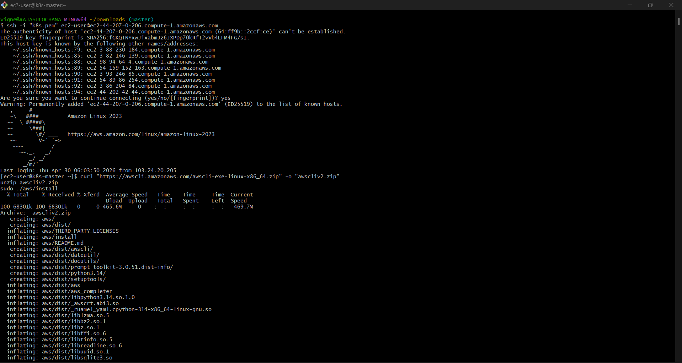
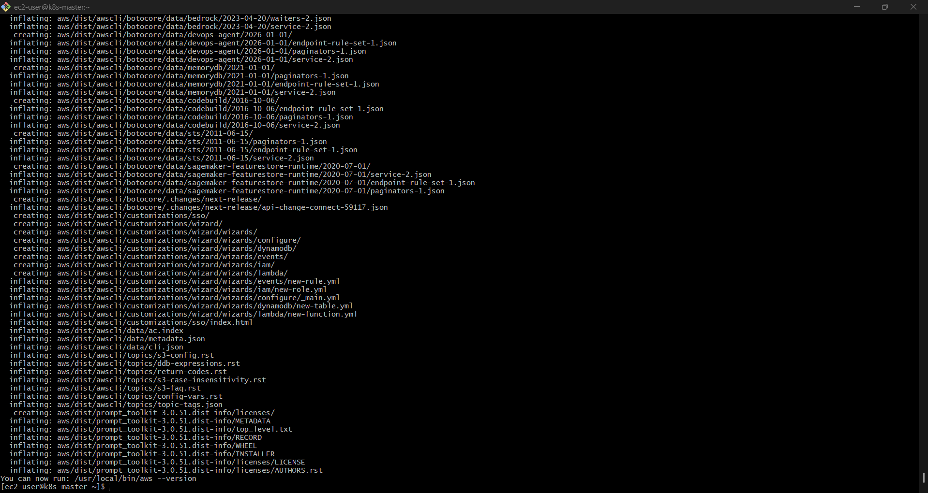

Check:
aws –version

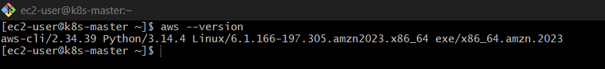

✅ 3. Configure AWS CLI
aws configure
Enter:
- Access Key
- Secret Key
- Region (e.g., ap-south-1)
- Output format (json)
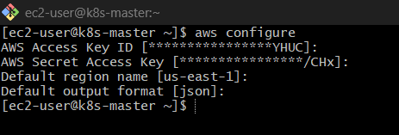

✅ 4. Install kubectl
Step 1: Remove wrong file
sudo rm -f /usr/local/bin/kubectl

Step 2: Download correct kubectl
Use this official working command:
curl -LO "https://dl.k8s.io/release/$(curl -s https://dl.k8s.io/release/stable.txt)/bin/linux/amd64/kubectl"

Step 3: Make it executable
chmod +x kubectl

Step 4: Move to PATH
sudo mv kubectl /usr/local/bin/

Step 5: Verify
kubectl version --client
✅ Now it should show proper version (not XML)

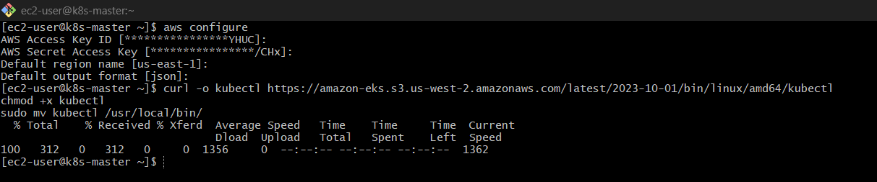
Check:
kubectl version –client
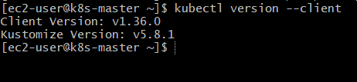

✅ 5. Install eksctl
curl --location "https://github.com/weaveworks/eksctl/releases/latest/download/eksctl_$(uname -s)_amd64.tar.gz" | tar xz -C /tmp
sudo mv /tmp/eksctl /usr/local/bin
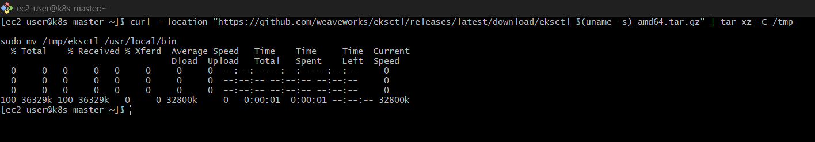
Check:
eksctl version
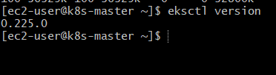

Step 2: Create EKS Cluster
🔹 Basic Command

eksctl create cluster \
--name my-cluster \
--region us-east-1 \
--nodegroup-name my-nodes \
--node-type t3.micro \
--nodes 2
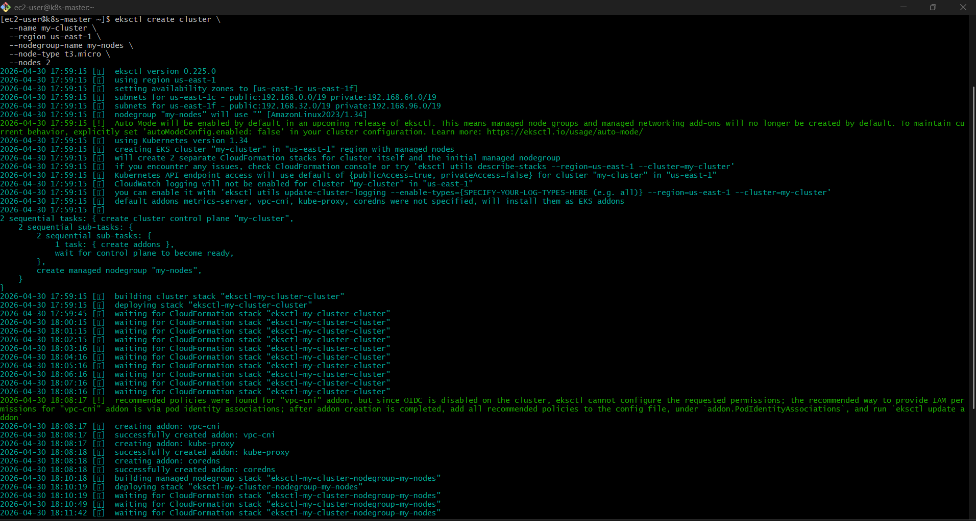
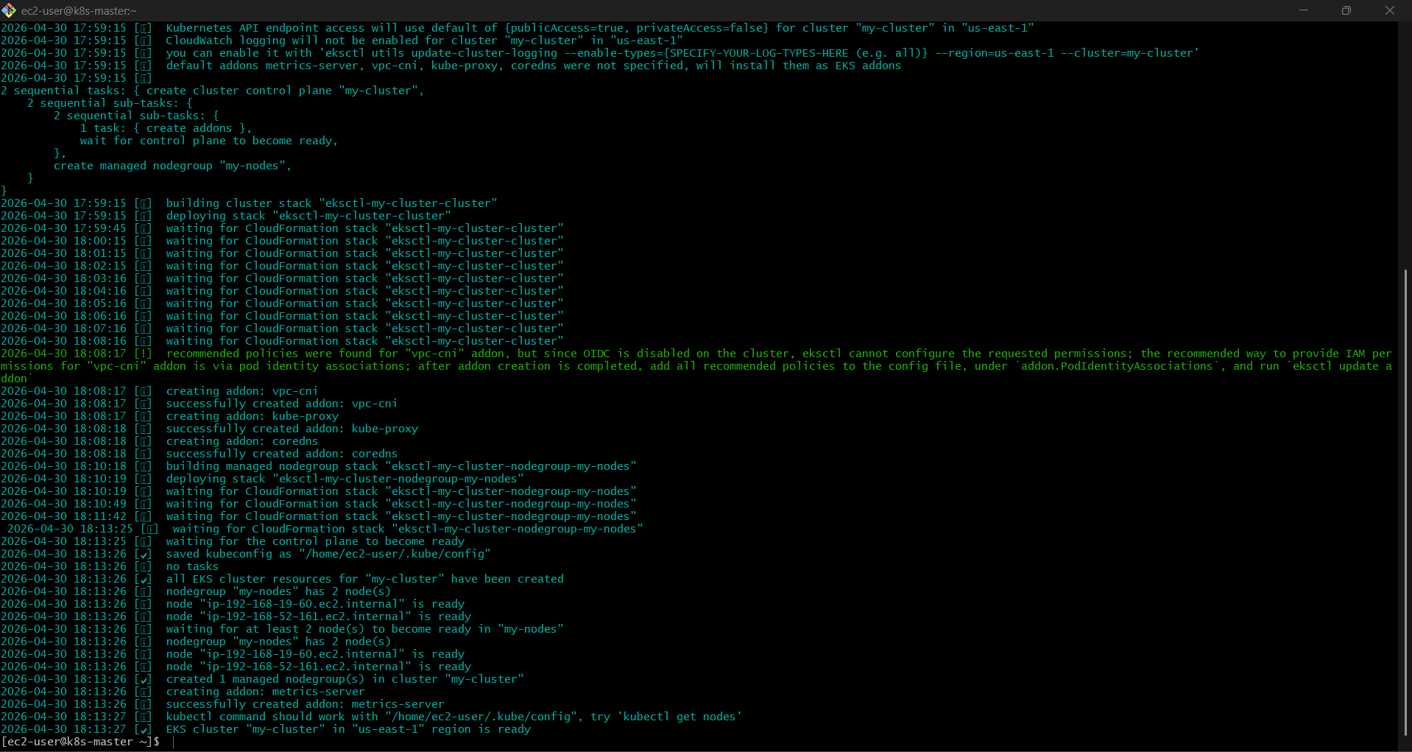

What this does:
- Creates EKS Control Plane
- Creates EC2 worker nodes
- Configures networking (VPC, subnets, etc.)
- Sets up IAM roles
Takes ~10–15 minutes

Verify In EKS

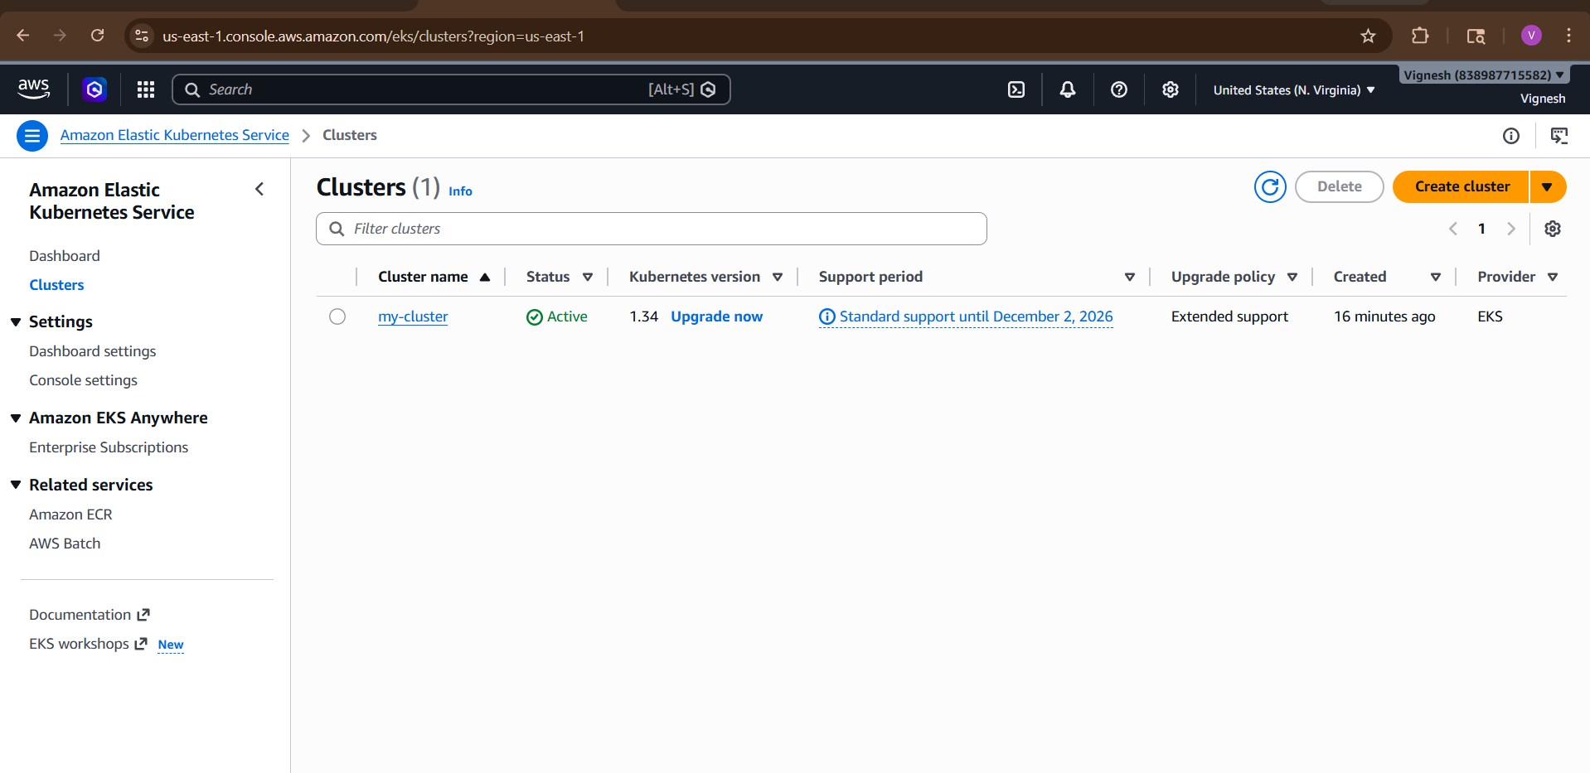

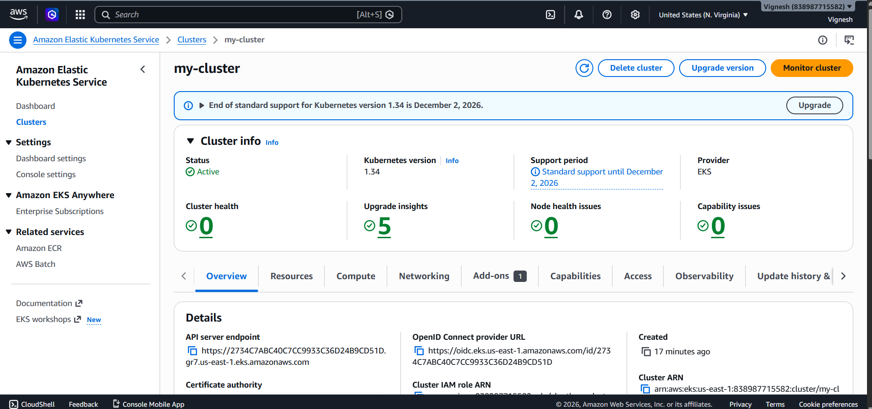

Verify In EC2

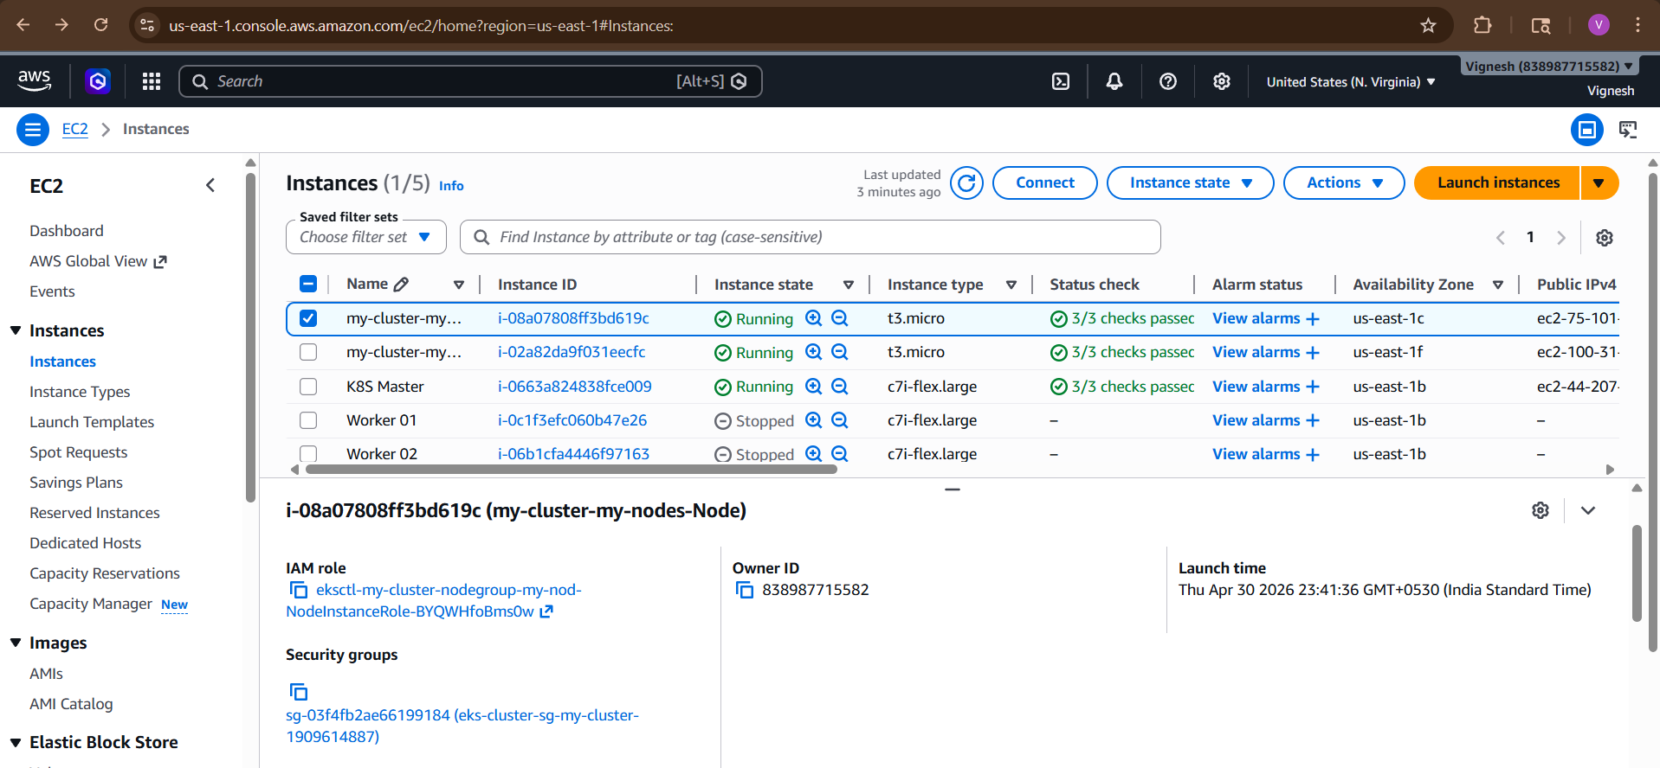

Step 3: Verify Cluster
Check nodes:
kubectl get nodes
You should see:
NAME STATUS ROLES AGE VERSION
ip-xxxx Ready <none> ...
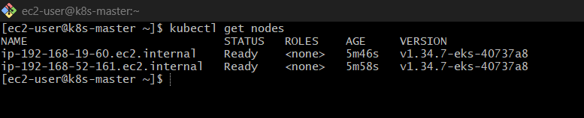

Check system pods:
kubectl get pods -A
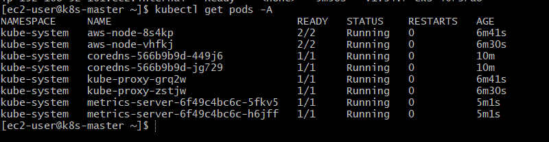

Step 4: Update kubeconfig (if needed)
Usually eksctl does it automatically, but if not:
aws eks update-kubeconfig \
--region ap-south-1 \
--name my-cluster

Step 5: Deploy Sample App
kubectl create deployment nginx --image=nginx
kubectl expose deployment nginx --type=NodePort --port=80
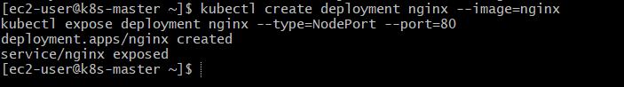
Check:
kubectl get svc
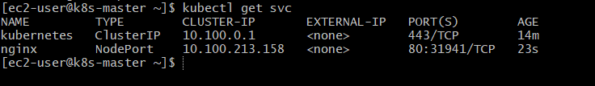

Get your worker node Public IP
Run this:
kubectl get nodes -o wide

You’ll see something like:
NAME STATUS ROLES EXTERNAL-IP
ip-xx-xx-xx Ready <none> 3.110.25.67

Step 6: Delete Cluster (Important )
To avoid AWS billing:
eksctl delete cluster --name my-cluster --region ap-south-1

What eksctl actually does:
Creates:
  - EKS Control Plane
  - Managed Node Group
  - VPC + Subnets
  - Security Groups
  - IAM Roles

Difference:
- Amazon EKS → Managed Kubernetes service
- eksctl → Tool to create/manage EKS easily

Pro Version (YAML Method)
Instead of CLI, use config file:
apiVersion: eksctl.io/v1alpha5
kind: ClusterConfig
metadata:
name: my-cluster
region: ap-south-1
nodeGroups:
- name: workers
instanceType: t2.micro
desiredCapacity: 2

Run:
eksctl create cluster -f cluster.yaml

Common Errors
❌ AccessDenied
👉 Fix IAM permissions
❌ Nodes not joining
👉 Check:
kubectl get nodes
❌ kubectl not working
👉 Re-run kubeconfig update

2) setup eks cluster using console

EKS Cluster Setup using Console (Step-by-Step)
We’ll use the AWS Management Console

Step 1: Go to EKS
- Open AWS Console
- Search EKS
- Click Elastic Kubernetes Service
👉 Click Create cluster

Step 2: Configure Cluster
Basic Details
- Name: my-cluster
- Kubernetes version: latest (default)
Cluster Service Role
👉 Click Create recommended role
This creates IAM role automatically (no headache 😄)
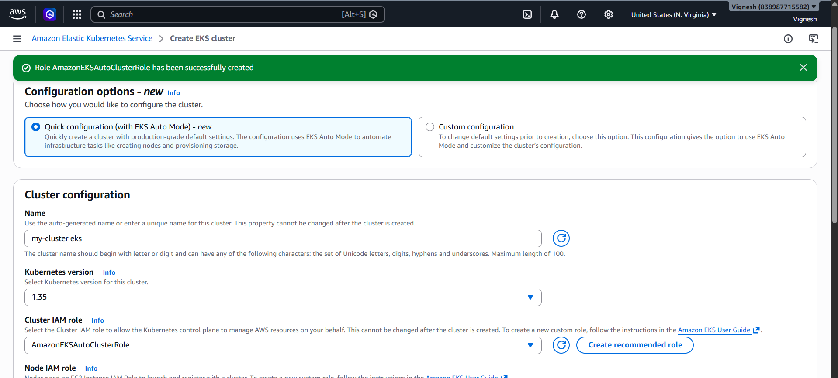
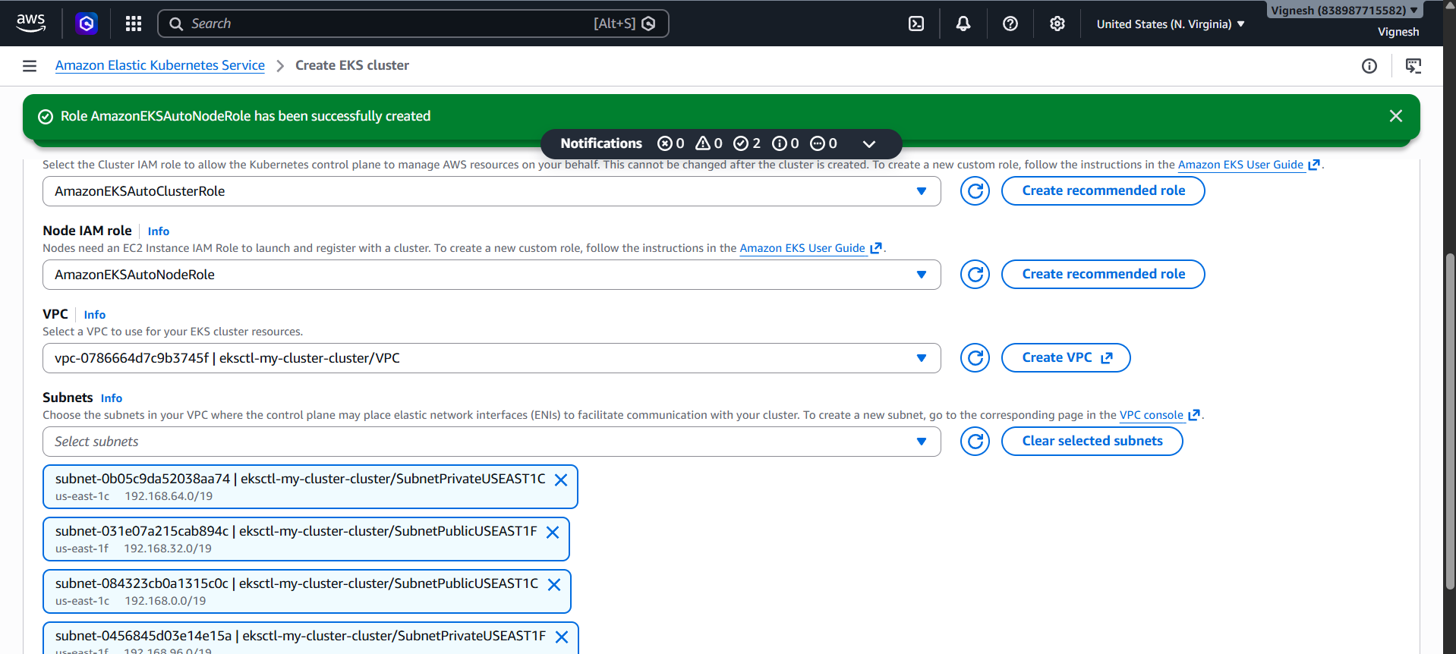

Step 3: Networking (VERY IMPORTANT)
- VPC: Select default VPC (for practice)
- Subnets: Select at least 2 subnets
- Cluster endpoint:
  - Public access ✅
  - Private access ❌ (for now)
👉 Click Next

Step 4: Logging (optional)
- You can skip or enable all logs (for learning skip is fine)
👉 Click Next → Create
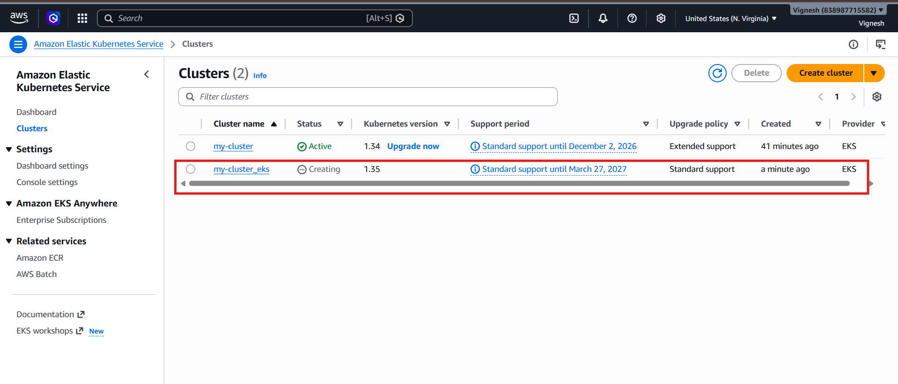

Step 5: Wait
- Cluster creation takes 10–15 minutes
- Status → ACTIVE

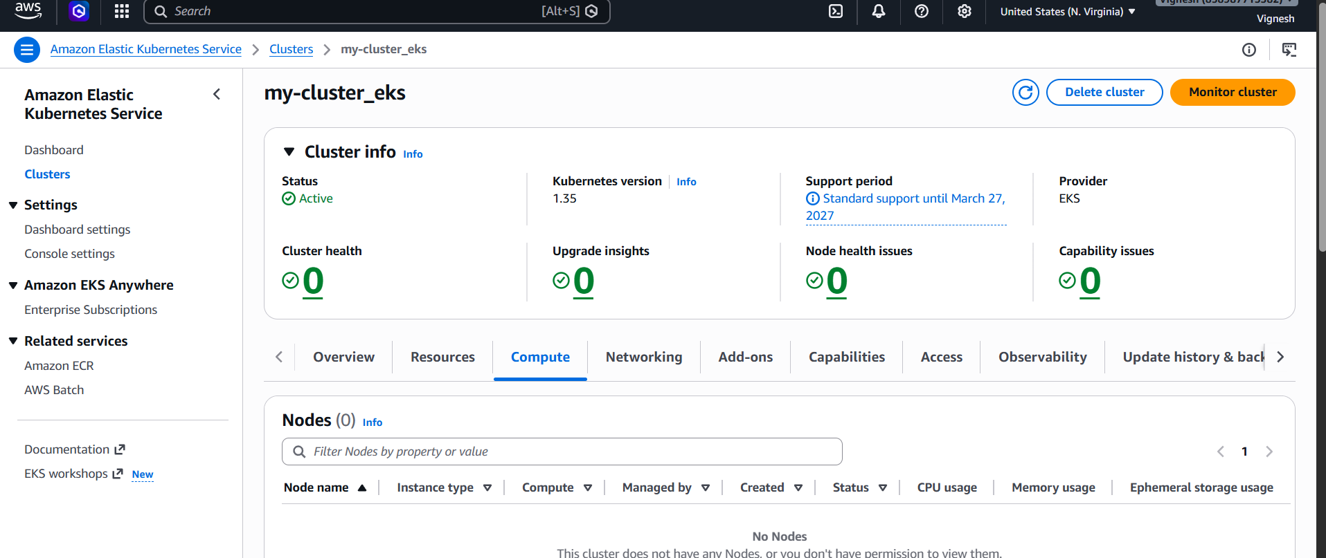

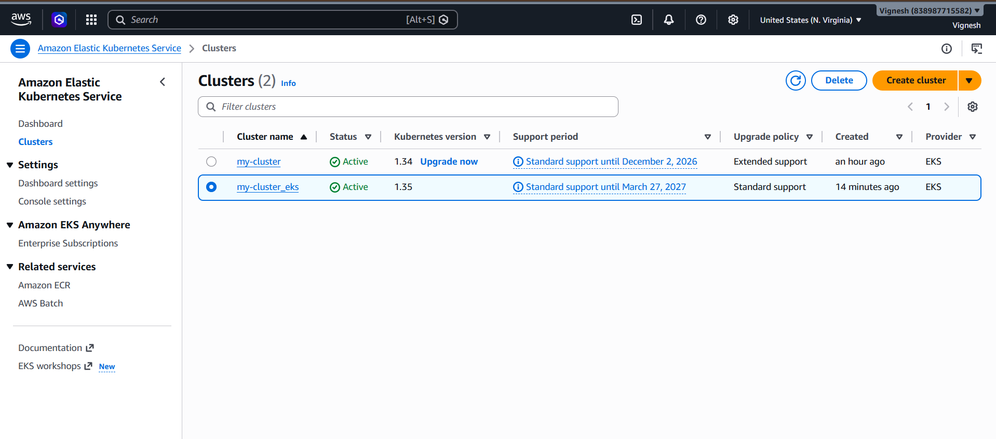

Step 6: Create Node Group (Workers)
Once cluster is ACTIVE:
👉 Go to your cluster → Compute → Add node group
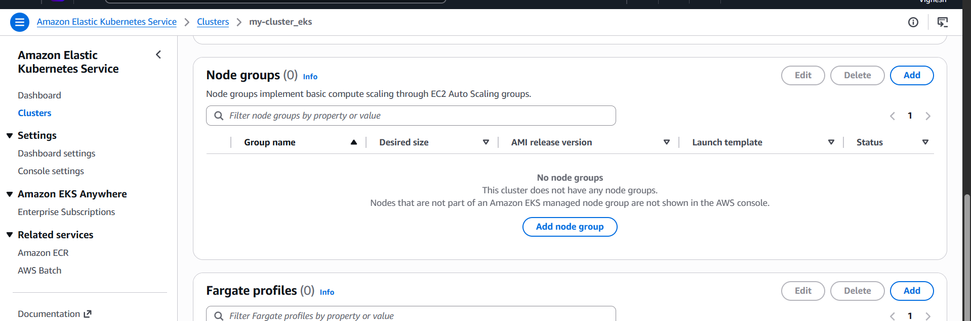

Node Group Settings
- Name: my-nodes
- Node role: Click Create new role
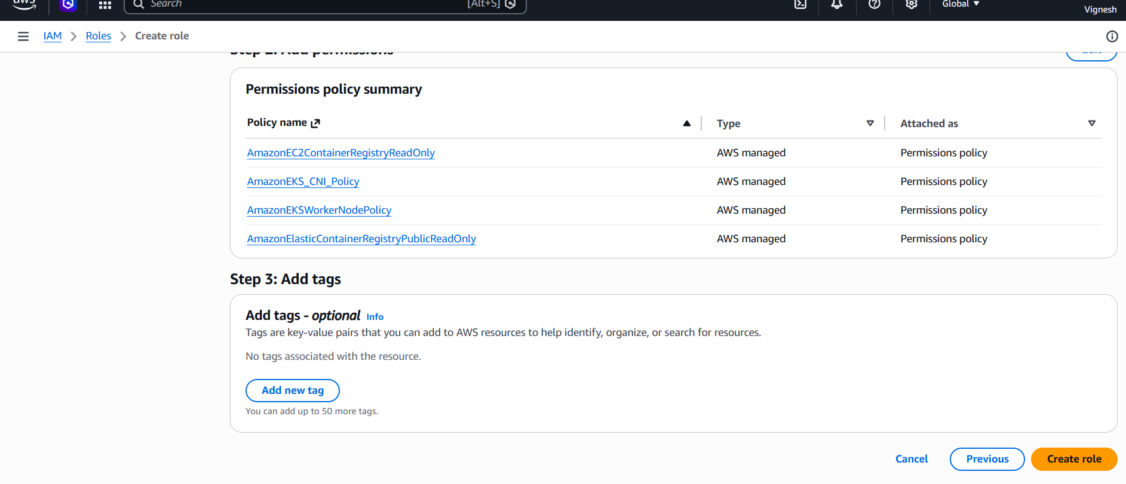

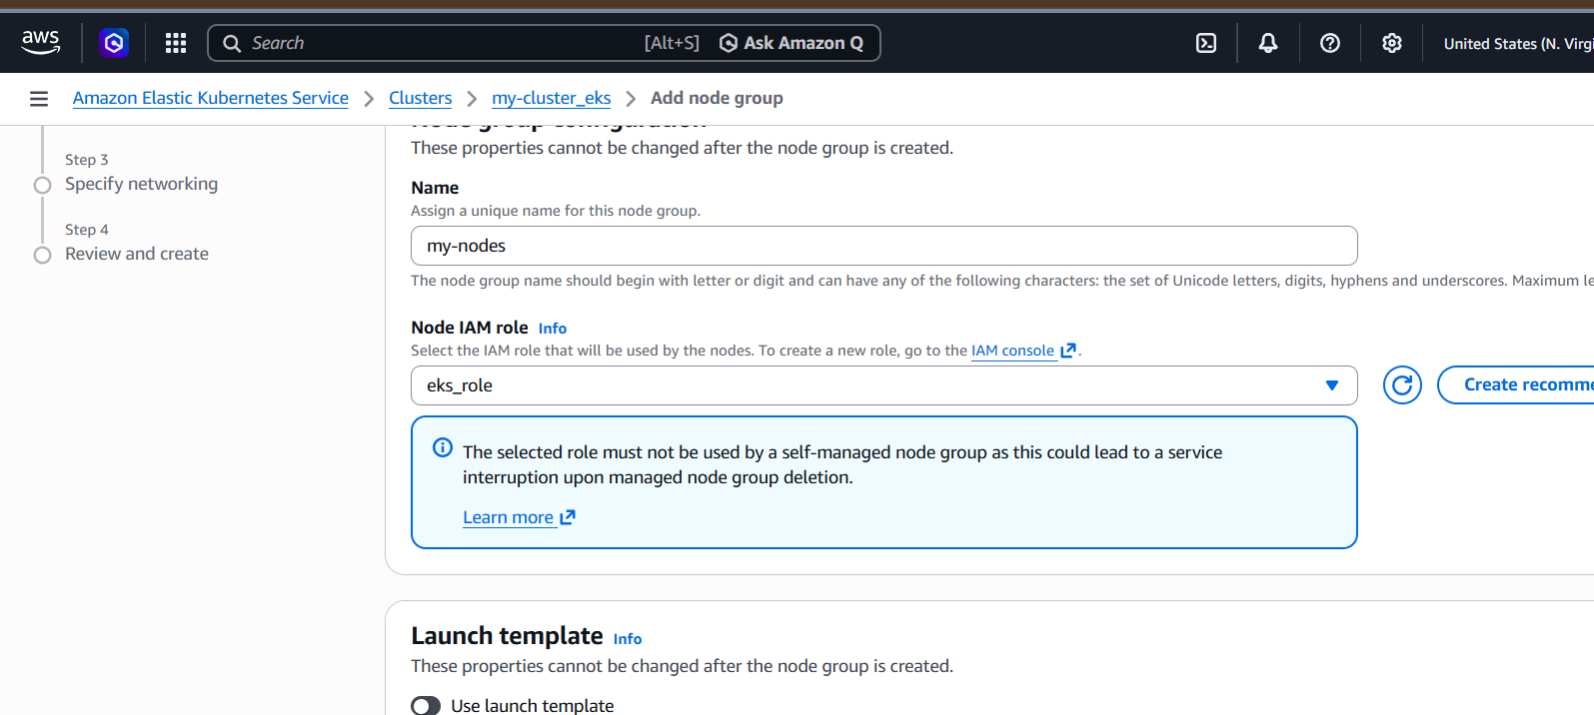

Instance settings
- AMI: Amazon Linux (default)
- Instance type: t3.micro
- Desired size: 2
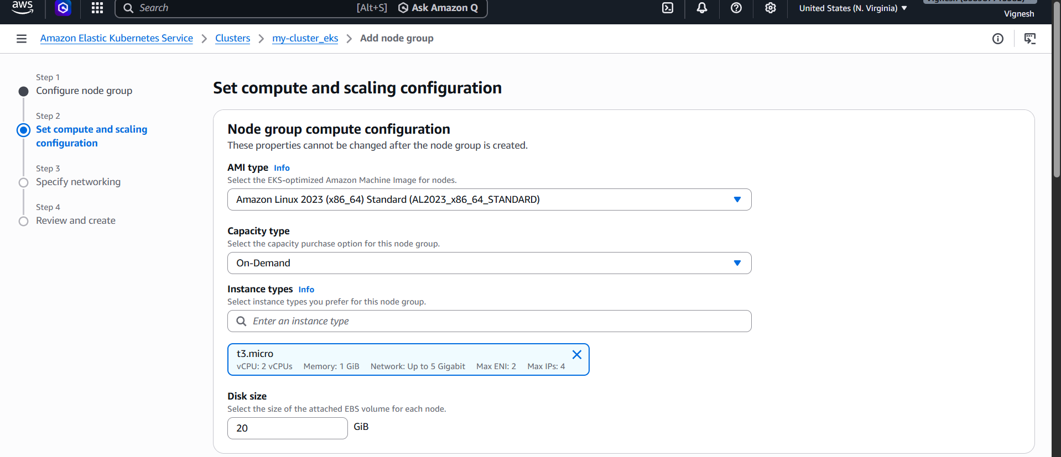

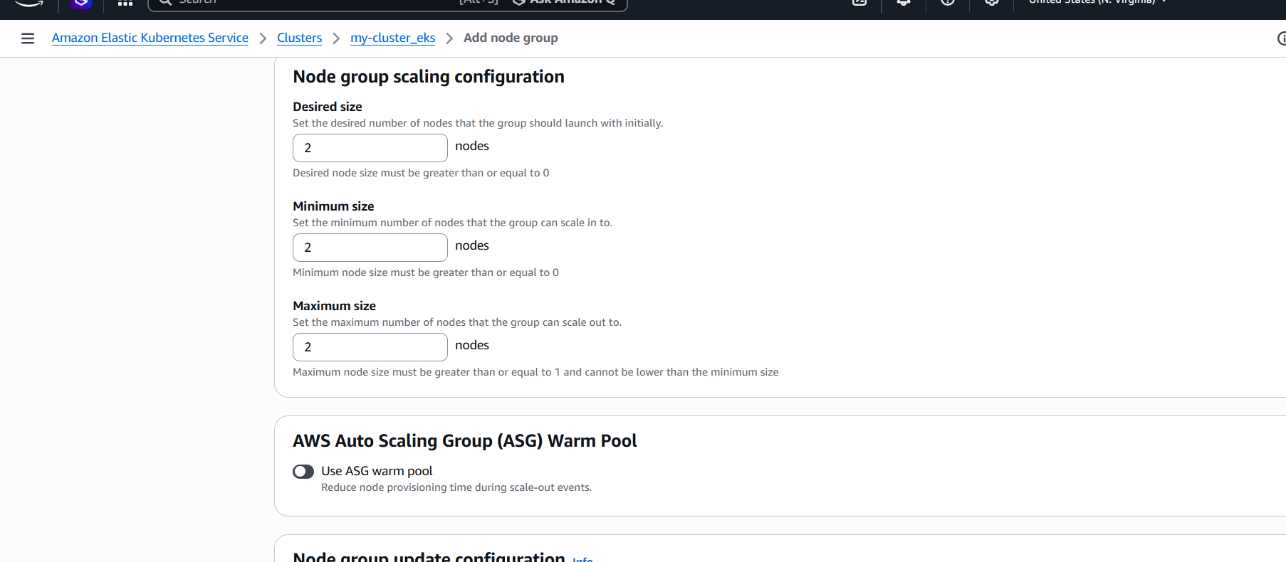

Networking
- Select same subnets
👉 Click Create
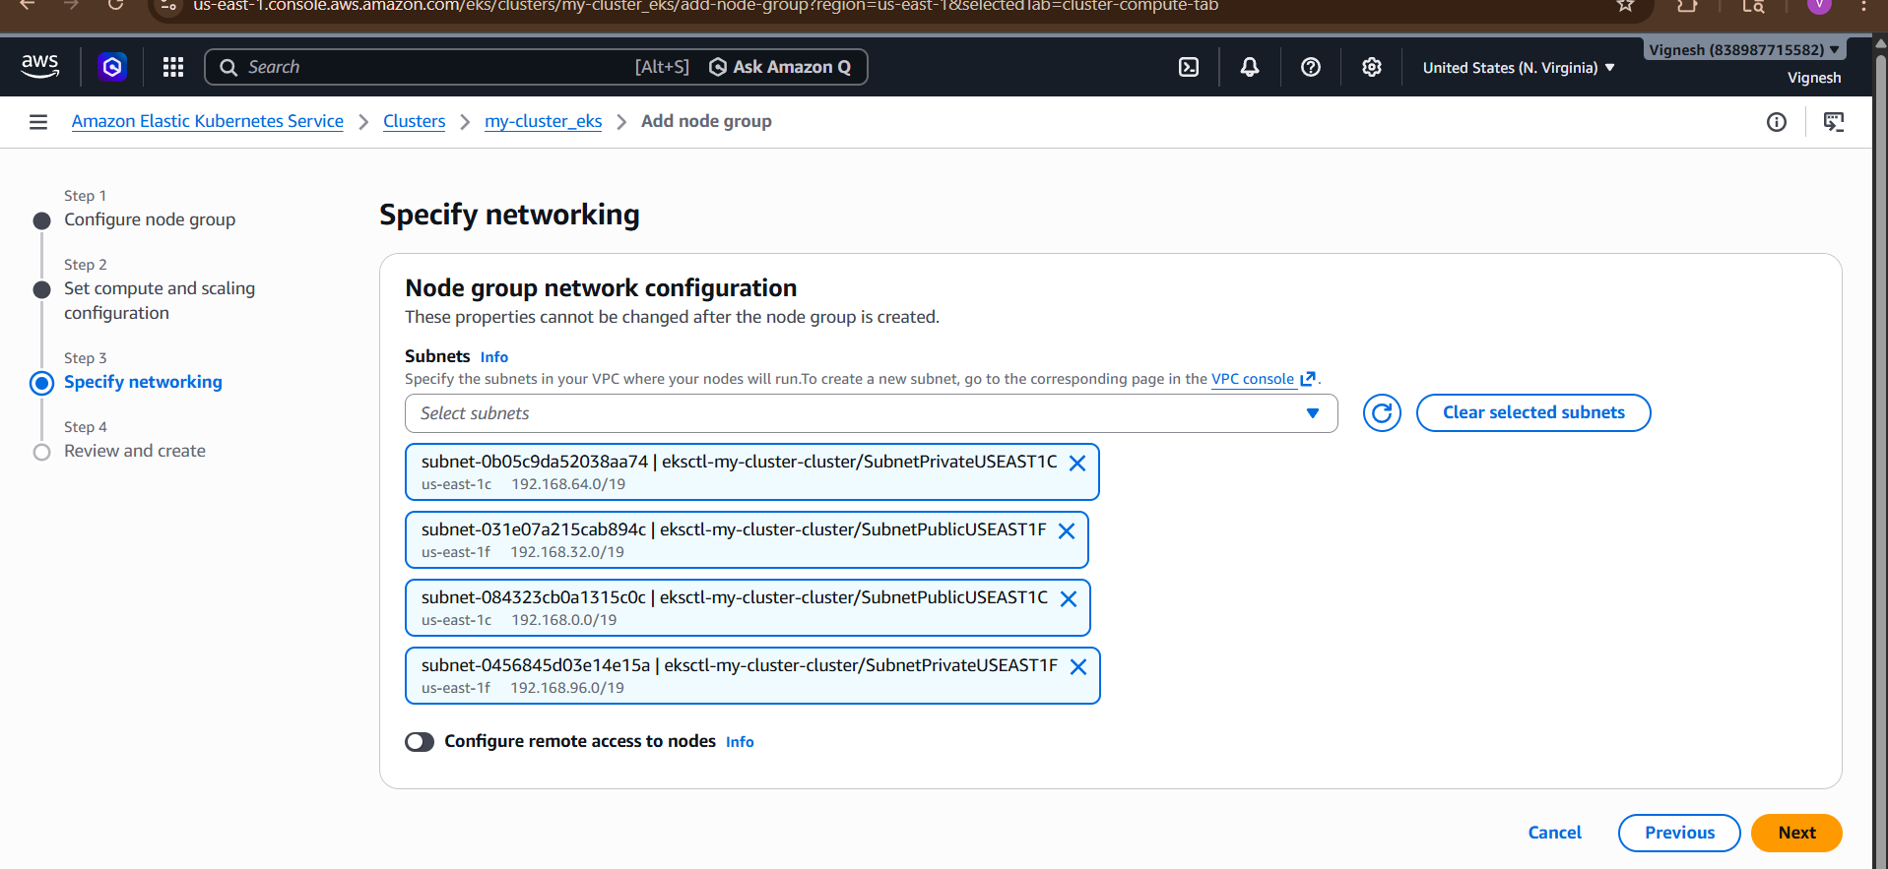

Wait again
Node group creation → ~5–10 minutes
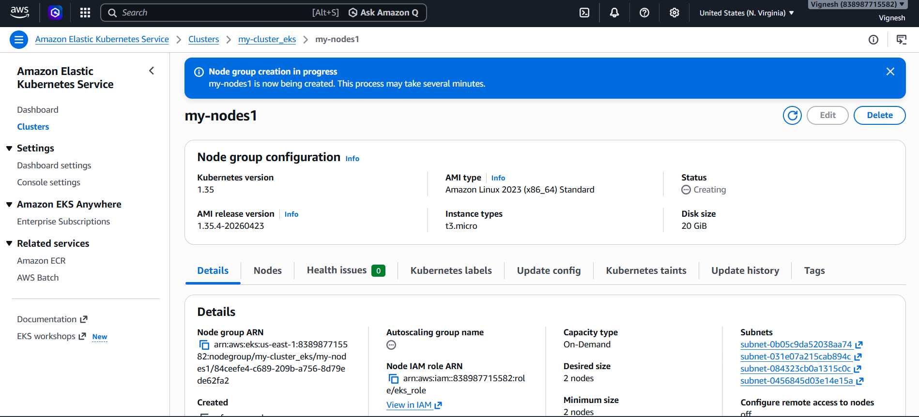
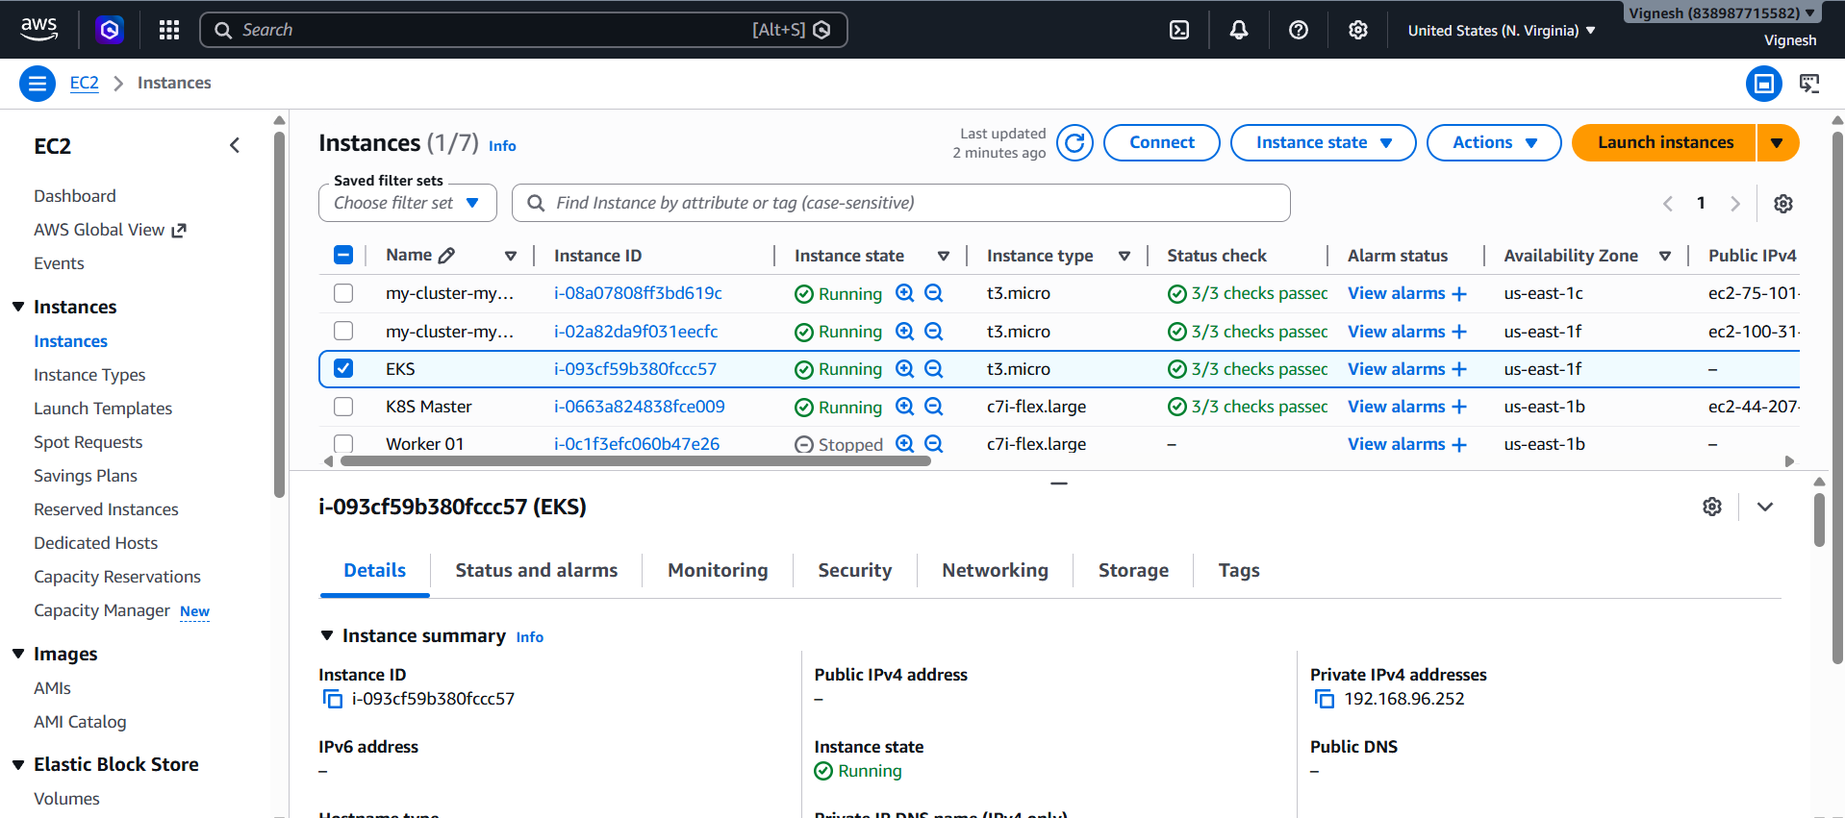

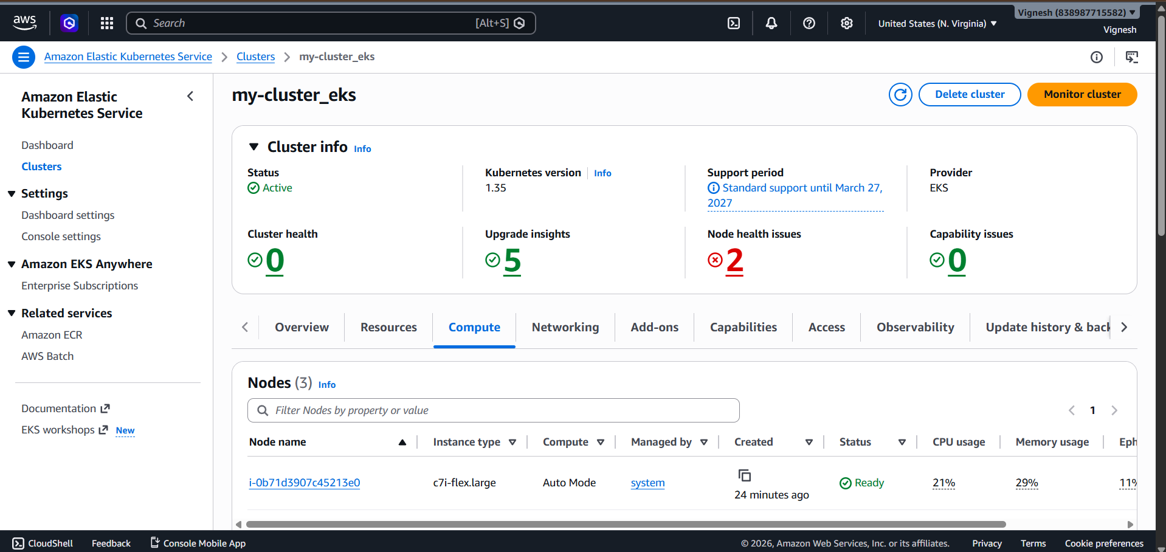

Step 7: Connect to Cluster
Run this on your EC2 or local machine:
aws eks update-kubeconfig \
--region us-east-1 \
--name my-cluster
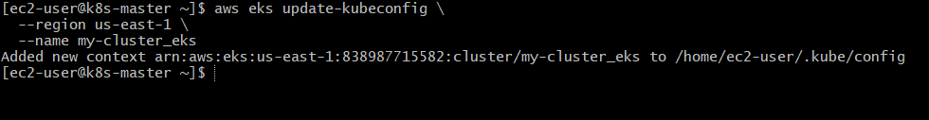

Go to 👉 AWS Management Console

Step 1: Open your cluster
- Go to EKS
- Click your cluster: my-cluster_eks

Step 2: Go to Add-ons tab
- Click Add-ons (left menu)
👉 You’ll likely see empty or missing core add-ons

Step 3: Add required add-ons
Click “Get more add-ons”
Now install these ONE BY ONE:

✅ 1. VPC CNI (MOST IMPORTANT)
- Name: Amazon VPC CNI
- Version: Latest
- Click → Create
👉 This fixes:
NetworkPluginNotReady

✅ 2. CoreDNS
- Name: CoreDNS
- Version: Latest
- Create

✅ 3. kube-proxy
- Name: kube-proxy
- Version: Latest
- Create

Step 4: Wait 2–5 minutes
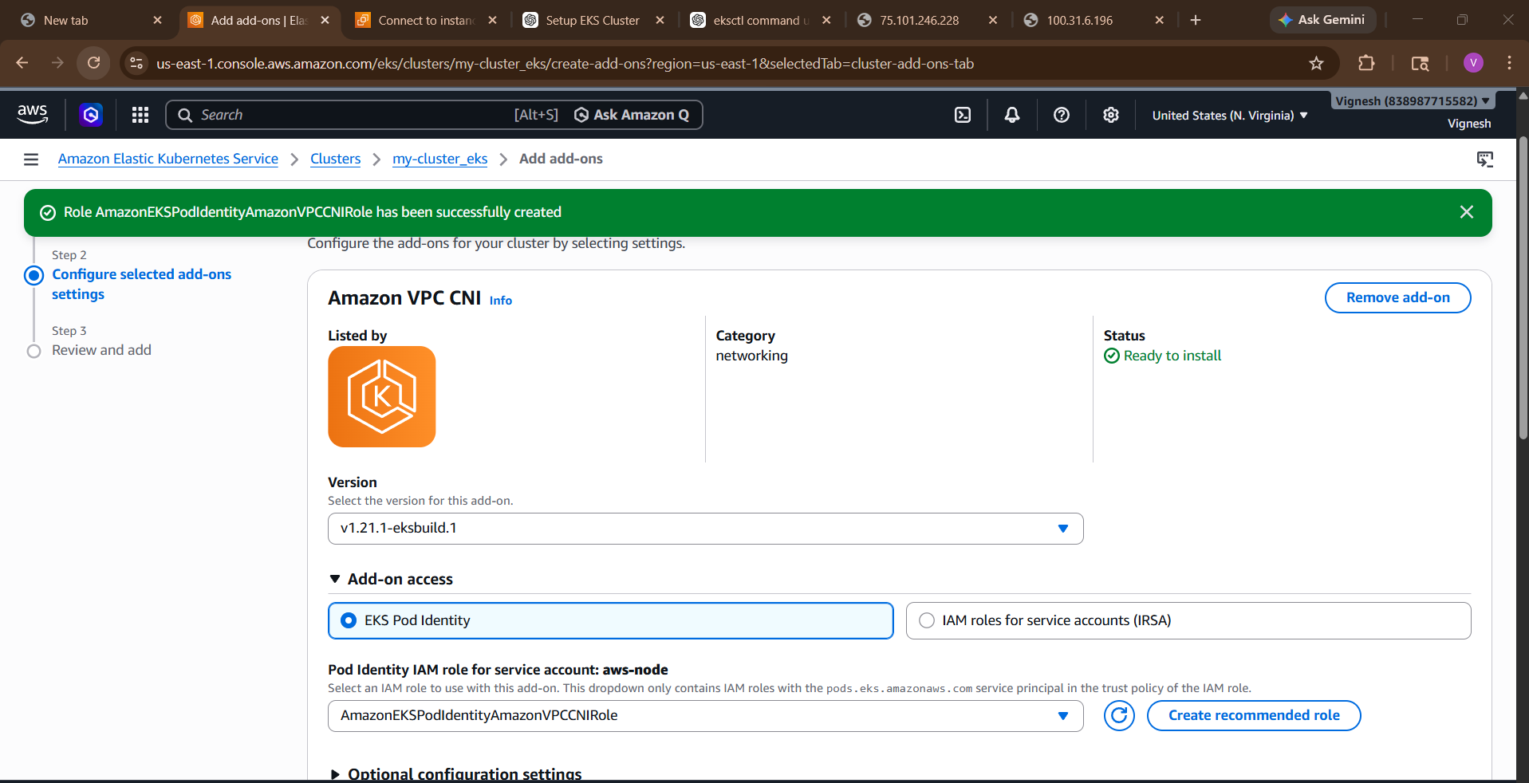
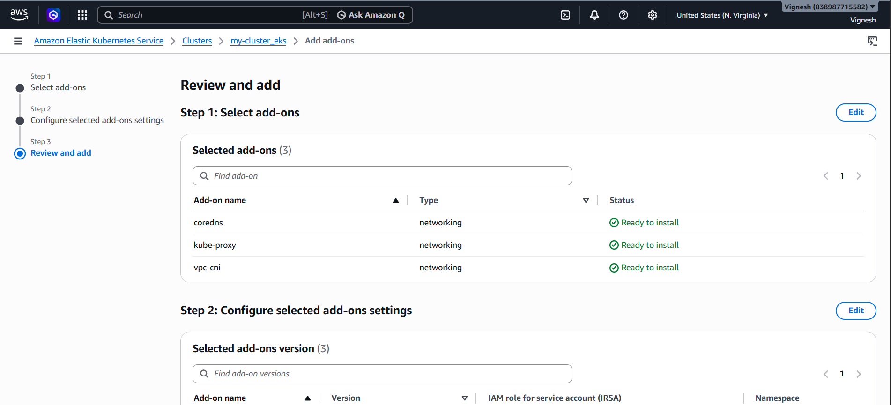

Step 5: Verify
Go back to terminal:
kubectl get pods -n kube-system
You should now see:
aws-node Running ✅
coredns Running ✅
kube-proxy Running ✅
metrics-server Running ✅
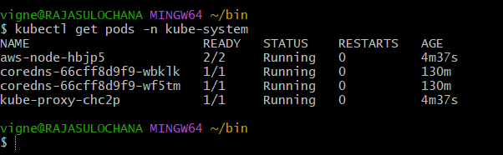

Step 6: Check nodes
kubectl get nodes
👉 Expected:
Ready Ready Ready ✅
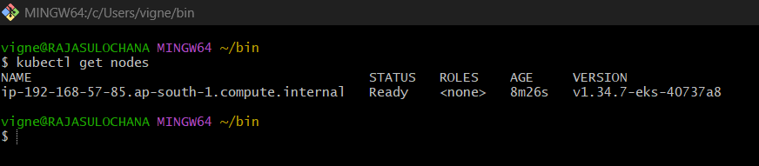

Done! Now test app
kubectl create deployment nginx --image=nginx
kubectl expose deployment nginx --type=NodePort --port=80
kubectl get svc

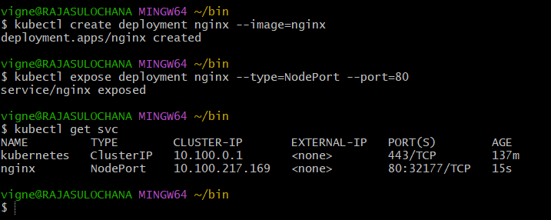

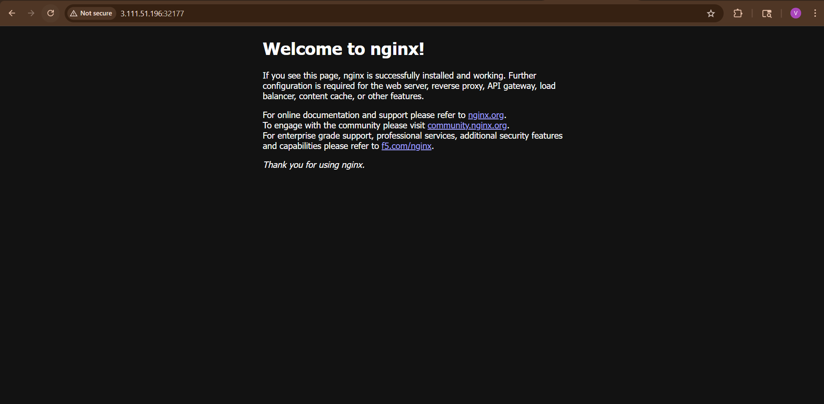

3) Setup HPA (Horizontal Pod Autoscaler)

What is HPA?
HPA automatically increases/decreases pods based on load (CPU/Memory)
👉 Example:
- Low load → 1 pod
- High load → 5 pods

IMPORTANT (Most people miss this)
HPA needs Metrics Server installed
👉 Without it → HPA will NOT work

Step 1: Install Metrics Server
Run:
kubectl apply -f https://github.com/kubernetes-sigs/metrics-server/releases/latest/download/components.yaml
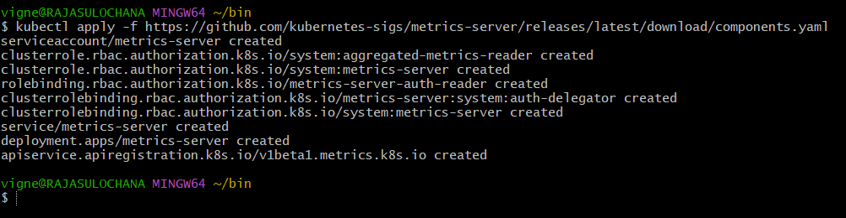

Verify Metrics Server
kubectl get pods -n kube-system
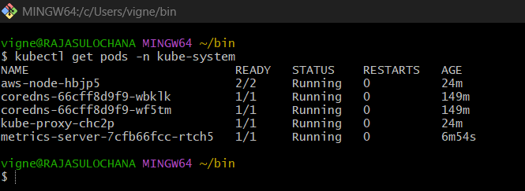
Then:
kubectl top nodes
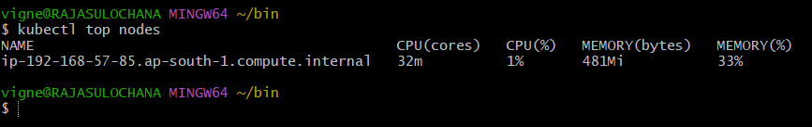
kubectl top pods
👉 If you see CPU values → working ✅
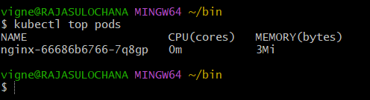

Step 2: Create Deployment
kubectl create deployment nginx --image=nginx
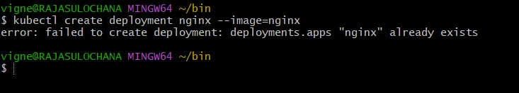

Step 3: Set CPU Requests (MANDATORY)
HPA works only if CPU requests are defined:
kubectl edit deployment nginx
Add:
resources:
requests:
cpu: "100m"
limits:
cpu: "200m"
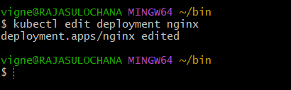

Step 4: Create HPA
kubectl autoscale deployment nginx \
--cpu-percent=50 \
--min=1 \
--max=5
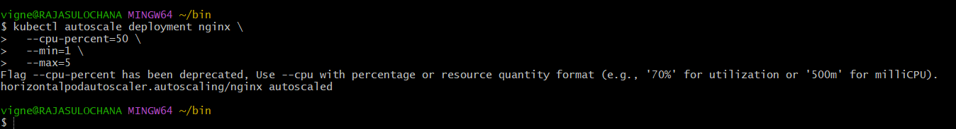

Step 5: Check HPA
kubectl get hpa
You’ll see:
TARGETS MINPODS MAXPODS REPLICAS

Expected:
NAME REFERENCE TARGETS MINPODS MAXPODS REPLICAS
nginx Deployment/nginx <xx%>/50% 1 5 1
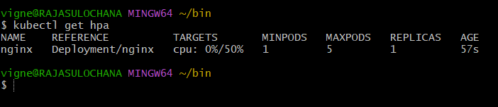

Step 6: Generate Load (IMPORTANT)
Run this:
kubectl run load-generator \
--image=busybox:1.28 \
--restart=Never \
-- //bin/sh -c "while true; do wget -q -O- http://nginx; done"
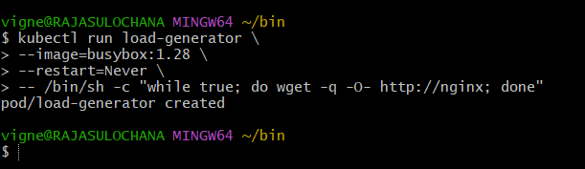

Watch scaling
kubectl get hpa -w
👉 Pods will increase automatically
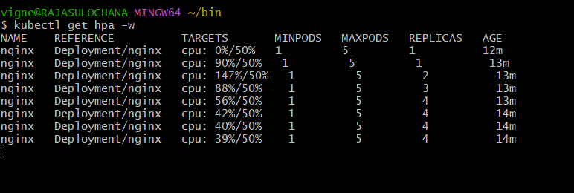
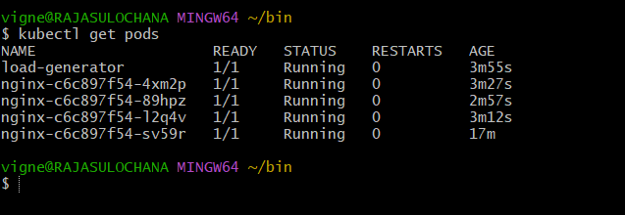
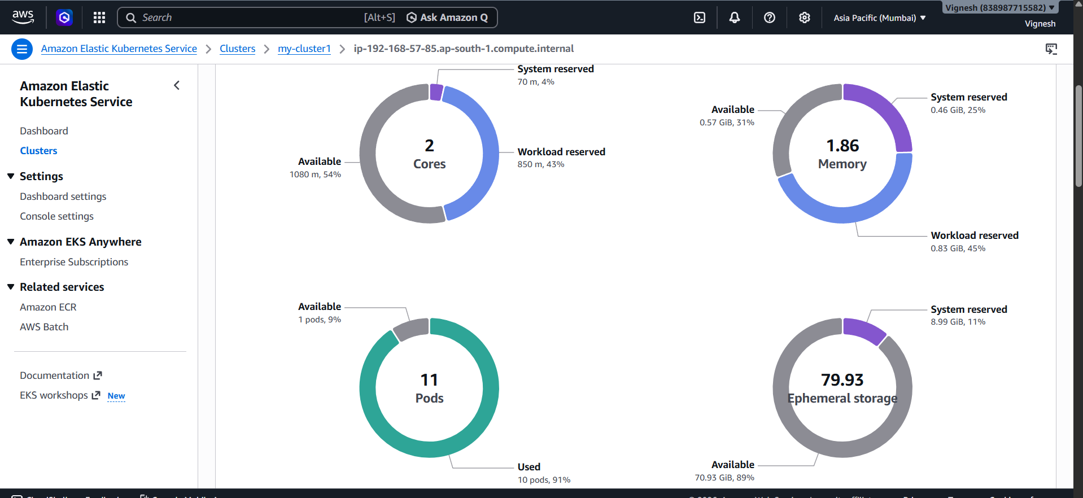

IMPORTANT POINTS
- HPA uses Metrics API
- Requires metrics-server
- Works on:
  - CPU ✔️
  - Memory ✔️
  - Custom metrics ✔️
- Needs resource requests defined

Common Errors
❌ metrics not available → metrics-server issue
❌ unknown CPU → no resource requests
❌ Not scaling → no load

4) Setup cluster autoscale

What is Cluster Autoscaler?
👉 Automatically:
- Adds nodes when pods can’t be scheduled
- Removes nodes when they’re idle
HPA = scales pods
Autoscaler = scales nodes

Before we start (VERY IMPORTANT)
You need:
- ✅ Node group (not Auto Mode only)
- ✅ Nodes should be Ready
- ✅ Instance type at least t3.small (recommended)
👉 If your nodes are still NotReady, fix that first.

STEP 1: Enable Auto Scaling on Node Group (Console)
Go to 👉 AWS Management Console
Path:
EKS → Cluster → Compute → Node group
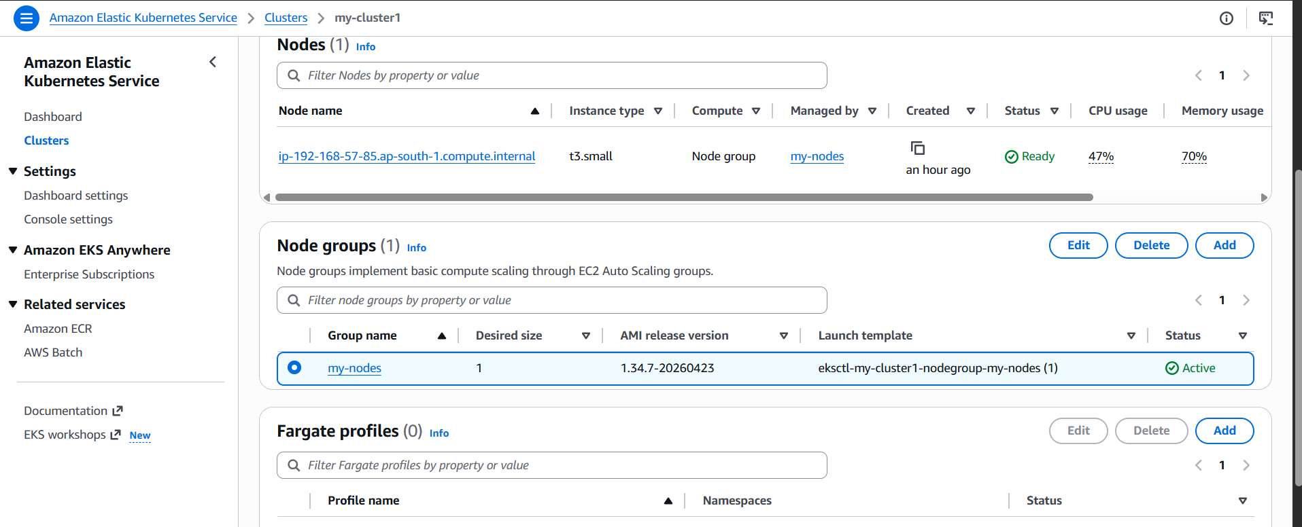
Click your node group → Edit:

Set:
- Min: 1
- Desired: 2
- Max: 4
👉 Save
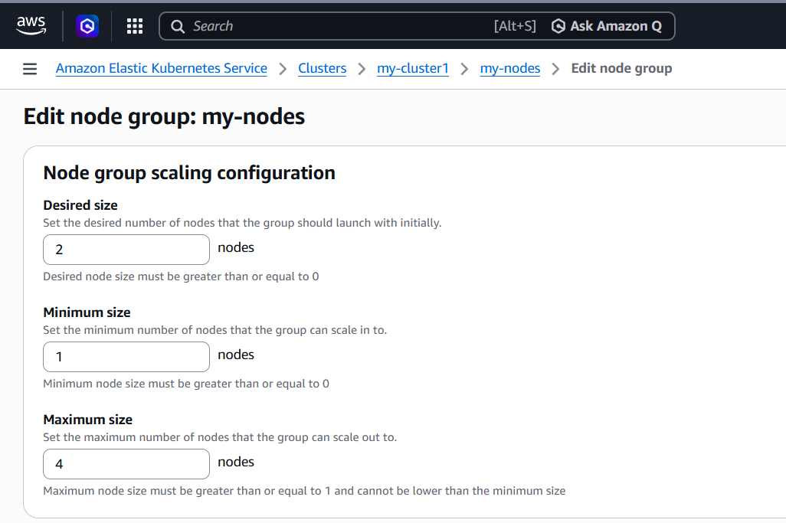

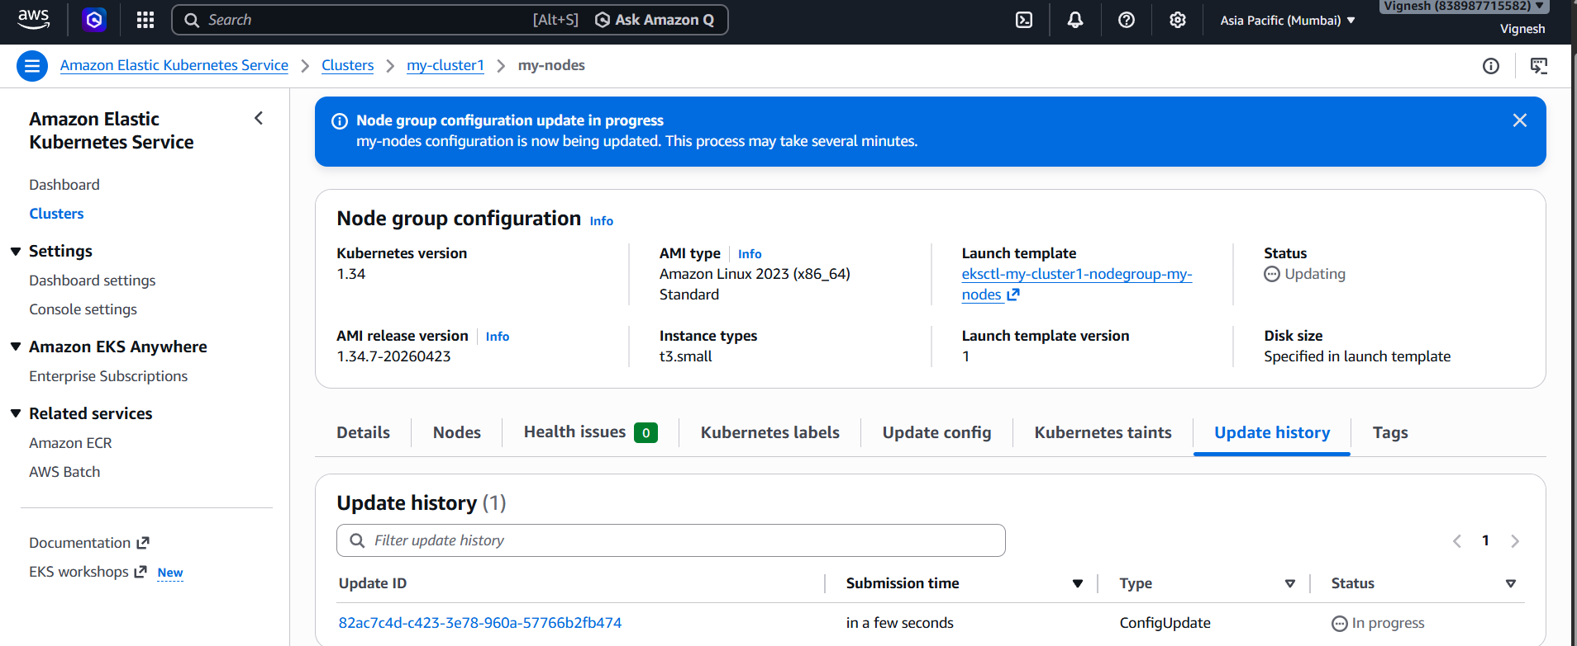

STEP 2: Attach IAM Policy (VERY IMPORTANT)
Go to:
👉 IAM → Roles → your node IAM role
Attach policy:
👉 Create policy (JSON):
{
"Version": "2012-10-17",
"Statement": [
{
"Action": [
"autoscaling:DescribeAutoScalingGroups",
"autoscaling:DescribeAutoScalingInstances",
"autoscaling:DescribeLaunchConfigurations",
"autoscaling:SetDesiredCapacity",
"autoscaling:TerminateInstanceInAutoScalingGroup",
"ec2:DescribeLaunchTemplateVersions"
],
"Effect": "Allow",
"Resource": "*"
}
]
}
Attach this to node role.
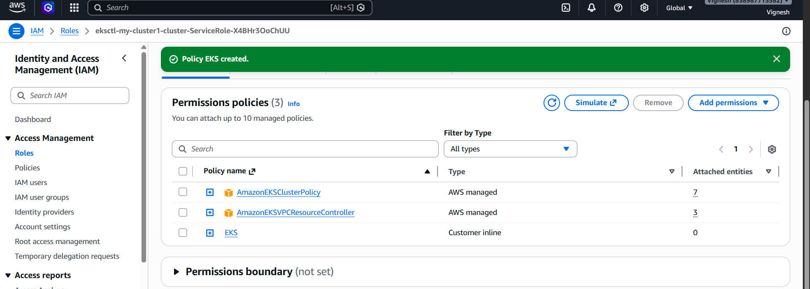

STEP 3: Add Tags to Node Group (CRITICAL)
Go to:
👉 EC2 → Auto Scaling Groups → your node group ASG
Add tags:
k8s.io/cluster-autoscaler/enabled = true
k8s.io/cluster-autoscaler/my-cluster_eks = owned
👉 Replace cluster name correctly
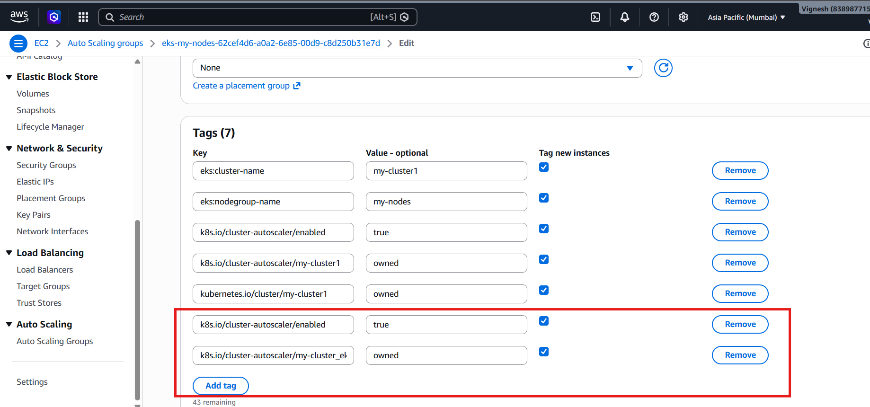

STEP 4: Deploy Cluster Autoscaler
Run this:
kubectl apply -f https://raw.githubusercontent.com/kubernetes/autoscaler/master/cluster-autoscaler/cloudprovider/aws/examples/cluster-autoscaler-autodiscover.yaml
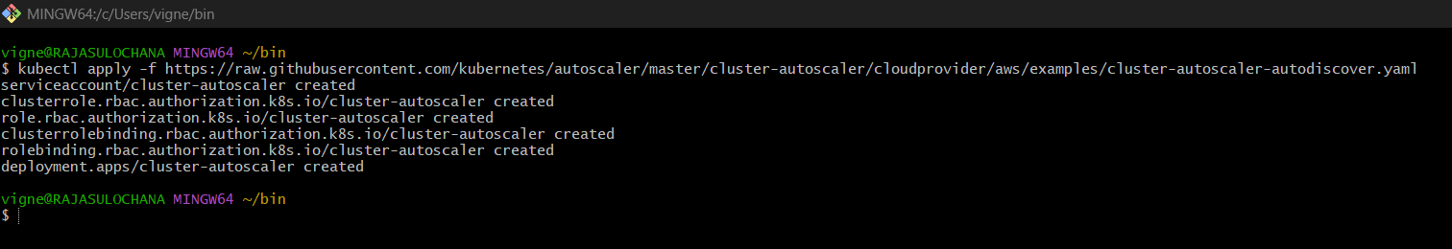

STEP 5: Edit deployment
kubectl edit deployment cluster-autoscaler -n kube-system
Find this line:
--cluster-name=<YOUR CLUSTER NAME>
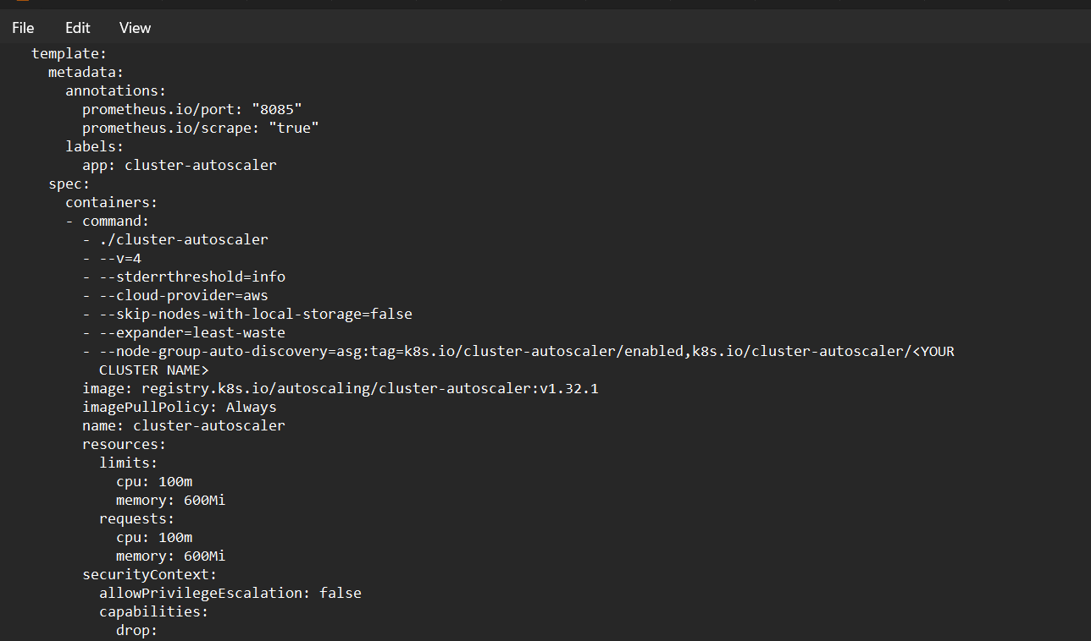
Replace with:
--cluster-name=my-cluster1_eks
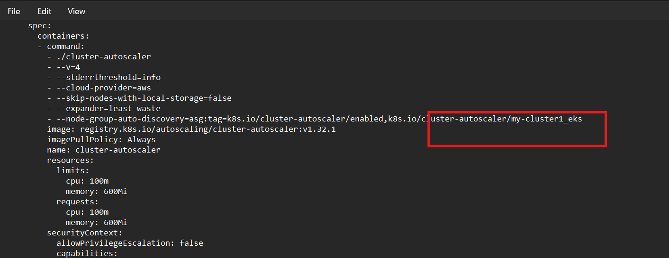

Add one more IMPORTANT flag
Under command: add:
--balance-similar-node-groups
--skip-nodes-with-system-pods=false
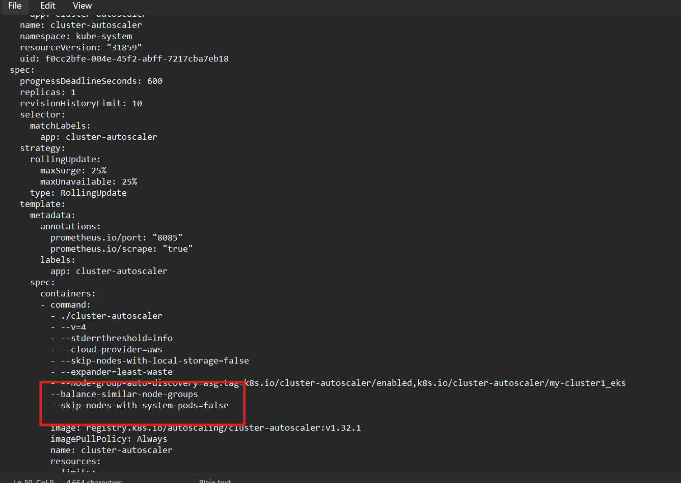

STEP 6: Verify
kubectl get pods -n kube-system
You should see:
cluster-autoscaler Running ✅

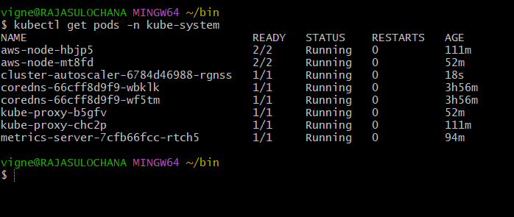

STEP 7: Test autoscaling
Create load:
Update BOTH requests + limits:
kubectl set resources deployment nginx \
--requests=cpu=1,memory=1Gi \
--limits=cpu=1,memory=1Gi
👉 Now:
- Requests = Limits
- Guaranteed heavy resource usage
- Perfect for triggering autoscaler
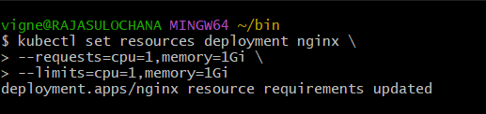

Then scale:
kubectl scale deployment nginx --replicas=10
👉 Pods will go Pending → CA will add nodes
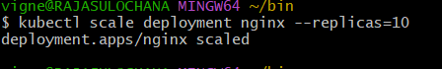
Verify
kubectl get deployment nginx
👉 Now should show:
DESIRED: 10
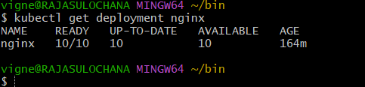Then:
kubectl get pods
👉 You MUST see:
- Some pods → Pending ✅
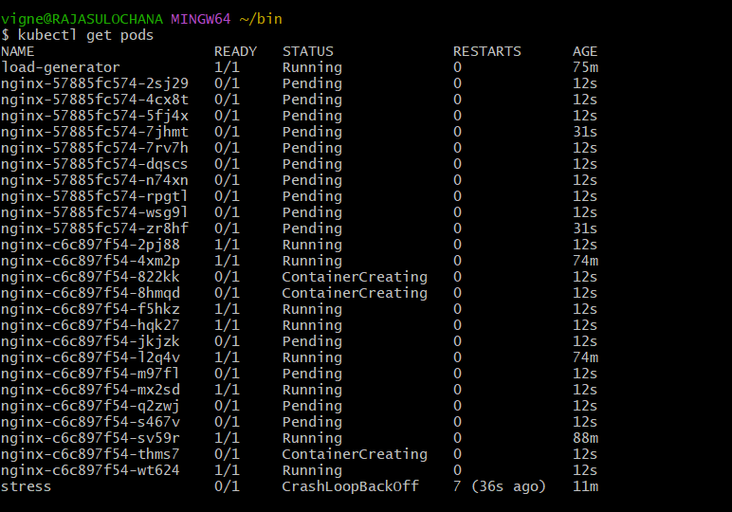

Watch scaling
kubectl get nodes -w

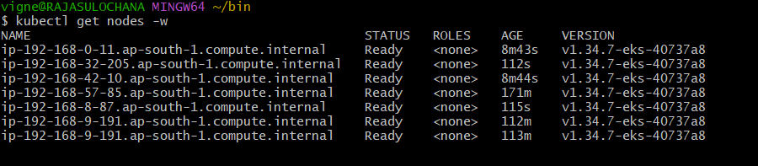
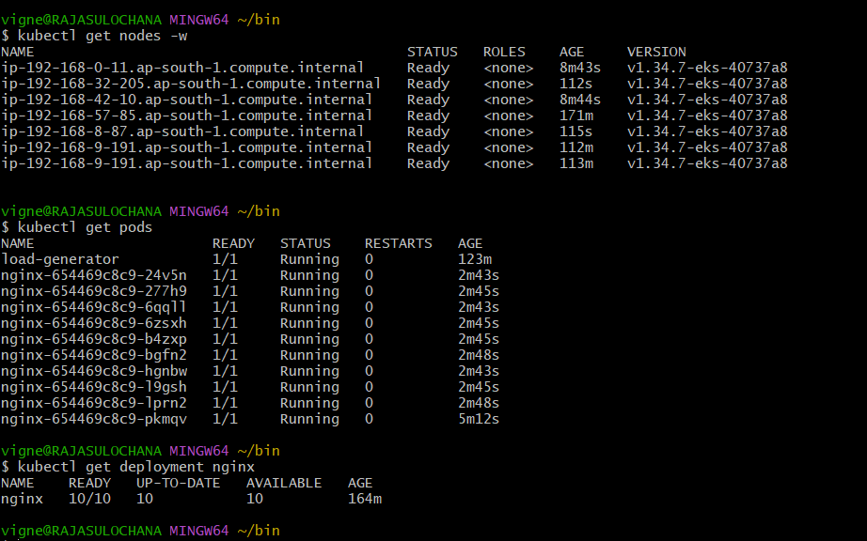

Important concepts
- CA works with Auto Scaling Group
- Needs tags to discover node groups
- Works only when pods are Pending
- Doesn’t scale if resources are enough

Common mistakes
❌ Wrong cluster name
❌ Missing tags
❌ Missing IAM permissions
❌ Using Auto Mode only (no ASG)

5) Setup cronjob and job

First — Concept (super simple)
🔹 Job
👉 Runs a task once and exits
Example: backup, script, migration

🔹 CronJob
👉 Runs task on schedule (like Linux cron)
Example: every day, every hour

PART 1 — Create a Job
✅ Step 1: Create YAML file
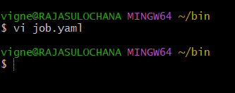
apiVersion: batch/v1
kind: Job
metadata:
name: my-job
spec:
completions: 1
parallelism: 1
template:
spec:
containers:
- name: job-container
image: busybox
command: ["sh", "-c", "echo Hello from Job && sleep 5"]
restartPolicy: Never
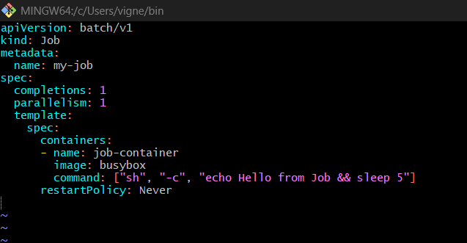

✅ Step 2: Apply
kubectl apply -f job.yaml
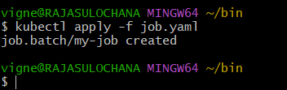

✅ Step 3: Check Job
kubectl get jobs
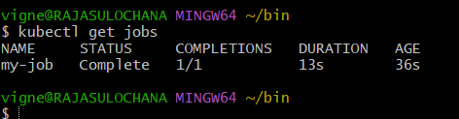

✅ Step 4: Check Pod
kubectl get pods
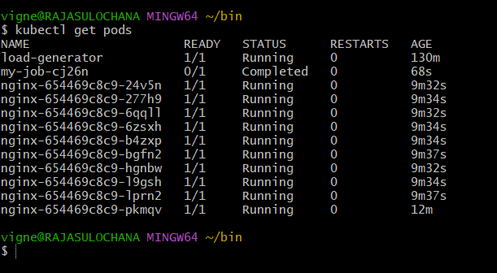

✅ Step 5: Check Logs
kubectl logs <job-pod-name>
kubectl logs my-job-cj26n
👉 Output:
Hello from Job
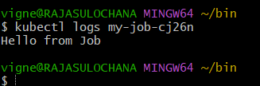

Difference between Deployment vs Job:
Feature |  | Deployment |  | Job
Purpose |  | Long-running apps |  | One-time task
Pod status |  | Running |  | Completed
Restart |  | Always |  | Based on completion
Example |  | Nginx, API server |  | Backup, batch task

PART 2 — Create a CronJob
✅ Step 1: Create YAML
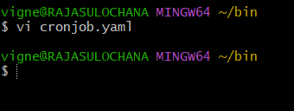
apiVersion: batch/v1
kind: CronJob
metadata:
name: my-cronjob
spec:
schedule: "*/1 * * * *" # every 1 minute
jobTemplate:
spec:
template:
spec:
containers:
- name: cron-container
image: busybox
command: ["sh", "-c", "date; echo Hello from CronJob"]
restartPolicy: Never
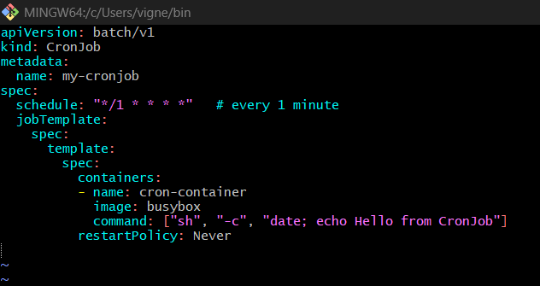

✅ Step 2: Apply
kubectl apply -f cronjob.yaml
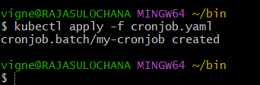

✅ Step 3: Check CronJob
kubectl get cronjobs
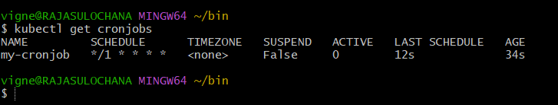

✅ Step 4: Watch Jobs being created
kubectl get jobs –watch
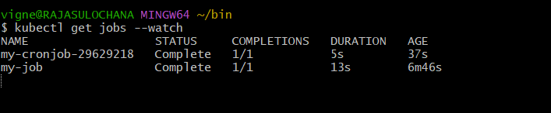
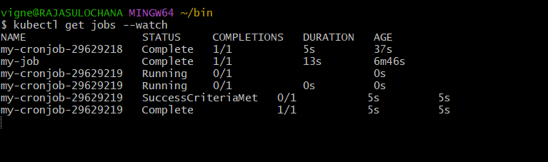
👉 Every 1 minute → new job created

✅ Step 5: Check Pods
kubectl get pods
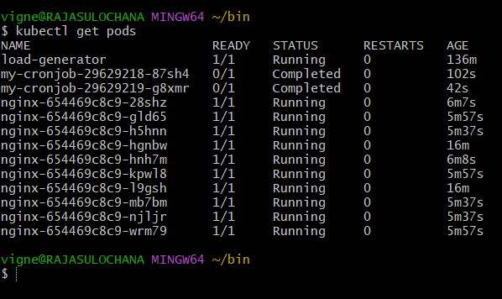

✅ Step 6: Logs
kubectl logs <cronjob-pod-name>
kubectl logs my-cronjob-29629218-87sh4
👉 Output:
Hello from CronJob
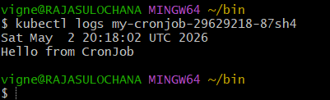

Cron Schedule Cheat Sheet
Schedule |  | Meaning
* * * * * |  | Every minute
*/5 * * * * |  | Every 5 mins
0 * * * * |  | Every hour
0 0 * * * |  | Daily midnight

Important Points
⭐ Job
- Runs once
- Ensures completion
- Can retry on failure

⭐ CronJob
- Creates Jobs on schedule
- Uses cron syntax
- Good for automation

Common Errors
❌ Pods not running
👉 Check:
kubectl describe pod <pod>

❌ CronJob not triggering
👉 Check time format

❌ Job stuck
👉 Check restartPolicy (must be Never)

6) Create secret and inject inside pod

What is a Secret?
👉 Kubernetes Secret = store sensitive data
- passwords
- API keys
- tokens
👉 Stored in base64 encoded format

PART 1 — Create Secret
✅ Method 1: Using CLI (fastest)
kubectl create secret generic my-secret \
--from-literal=username=admin \
--from-literal=password=12345
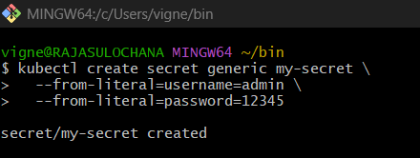

✅ Verify Secret
kubectl get secrets
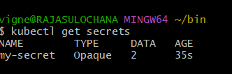
kubectl describe secret my-secret
👉 You’ll see encoded values
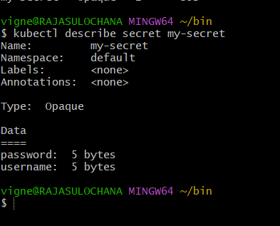

Optional: Decode Secret
echo YWRtaW4= | base64 --decode
👉 Output: admin

PART 2 — Inject Secret into Pod
We’ll inject in 2 ways (VERY IMPORTANT)

Method 1: Environment Variables
✅ Create Pod YAML
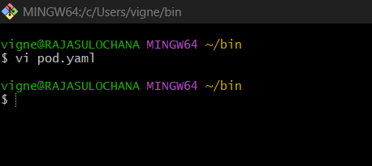
apiVersion: v1
kind: Pod
metadata:
name: secret-env-pod
spec:
containers:
- name: app
image: busybox
command: ["sh", "-c", "env && sleep 3600"]
env:
- name: USERNAME
valueFrom:
secretKeyRef:
name: my-secret
key: username
- name: PASSWORD
valueFrom:
secretKeyRef:
name: my-secret
key: password
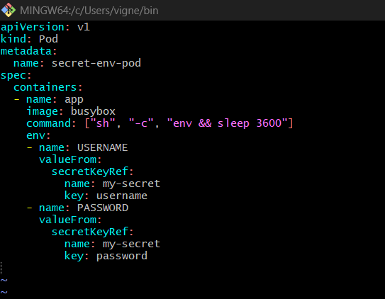

✅ Apply
kubectl apply -f pod.yaml
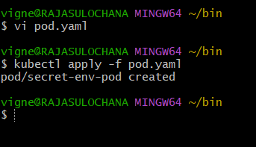

✅ Check logs
kubectl logs secret-env-pod
👉 Output includes:
USERNAME=admin
PASSWORD=12345
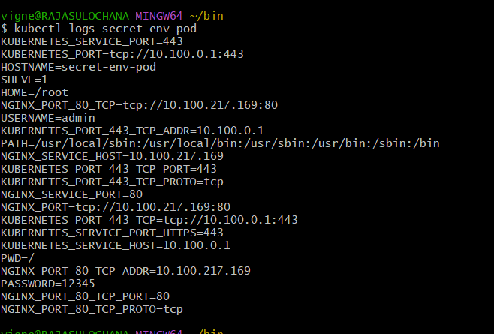

Method 2: Mount as File
✅ Pod YAML
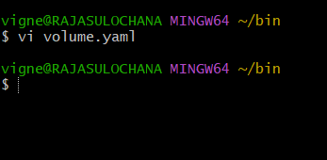
apiVersion: v1
kind: Pod
metadata:
name: secret-volume-pod
spec:
containers:
- name: app
image: busybox
command: ["sh", "-c", "sleep 3600"]
volumeMounts:
- name: secret-volume
mountPath: /etc/secret
volumes:
- name: secret-volume
secret:
secretName: my-secret
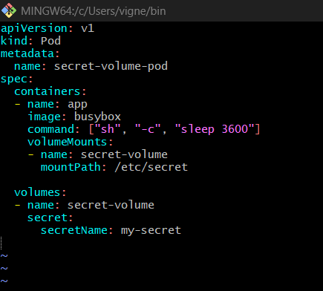

✅ Apply
kubectl apply -f volume.yaml
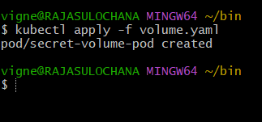

✅ Check inside pod
winpty kubectl exec -it secret-volume-pod – sh
👉 winpty fixes the TTY issue on Git Bash
👉 This should drop you inside the container shell
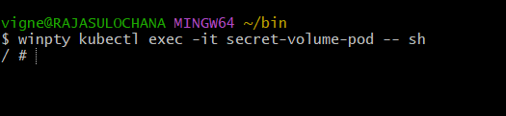
cd /etc/secret
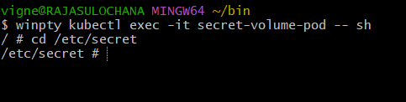
ls
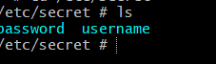
cat username
cat password
👉 Output:
admin
12345
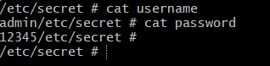

Key Difference
Method | Use Case
Env vars | Simple apps
Volume | Secure + production

Important Points
- Secrets are base64 encoded (not encrypted by default)
- Better security:
  - Use IAM / external secret manager
- Avoid hardcoding credentials ❌

7) Check differen add-ons available on eks.

First — What are EKS Add-ons?
In Amazon EKS, add-ons are:
👉 AWS-managed components that run inside your cluster
Examples:
- VPC CNI (networking)
- CoreDNS (DNS)
- kube-proxy (network routing)

PART 1 — Check Add-ons using AWS Console (EASIEST)
✅ Step 1: Open EKS
Go to:
👉 AWS Console → EKS → Clusters

✅ Step 2: Select your cluster
Click your cluster name (e.g., my-cluster)

✅ Step 3: Go to Add-ons tab
👉 Click “Add-ons”

You will see list like:
- Amazon VPC CNI
- CoreDNS
- kube-proxy
- (Optional ones if installed)
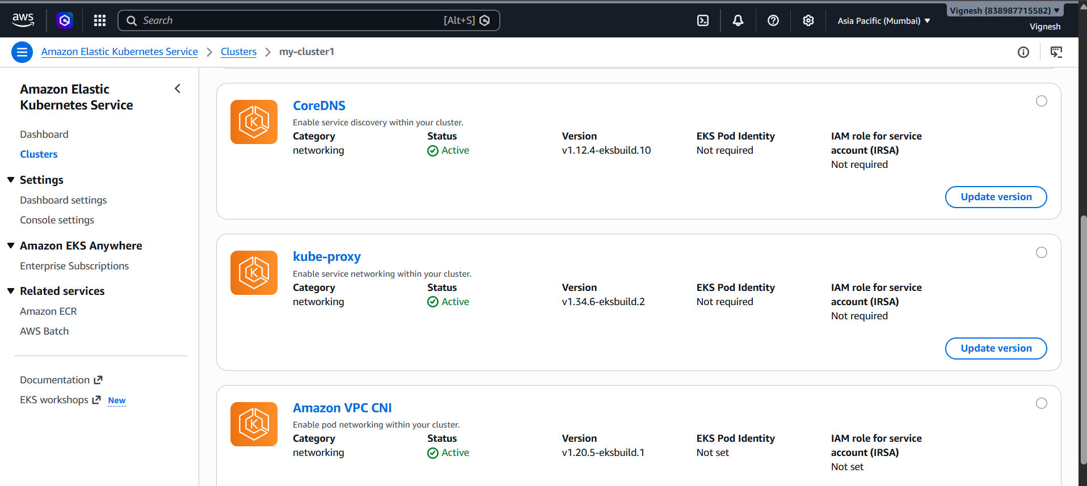

✅ Step 4: Click any add-on
You’ll see:
- Version
- Status
- IAM role
- Health

PART 2 — Check using CLI (Powerful way)

✅ Step 1: List installed add-ons

aws eks list-addons --cluster-name my-cluster1
👉 Output:
{
"addons": [
"vpc-cni",
"coredns",
"kube-proxy"
]
}
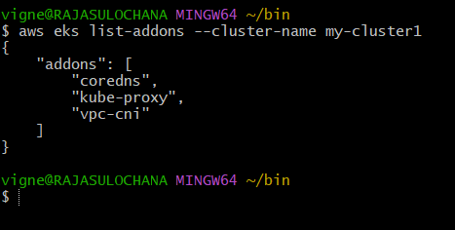

✅ Step 2: Describe specific add-on
aws eks describe-addon \
--cluster-name my-cluster1 \
--addon-name vpc-cni

👉 Shows:
- version
- status
- IAM role
- configuration
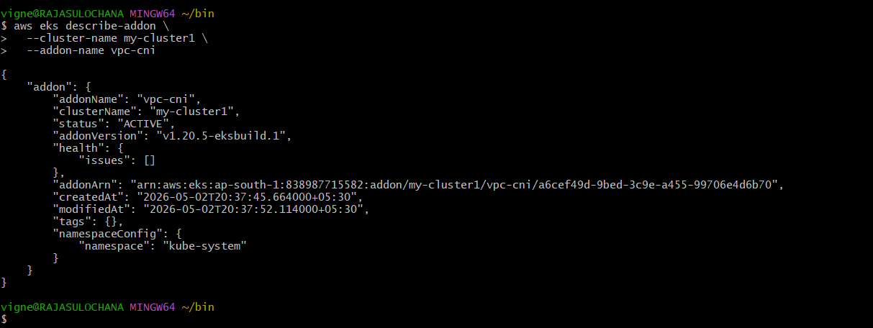

PART 3 — List ALL available add-ons (Important )
✅ Step 1: List add-ons supported by EKS
aws eks describe-addon-versions
👉 This shows ALL add-ons supported by AWS
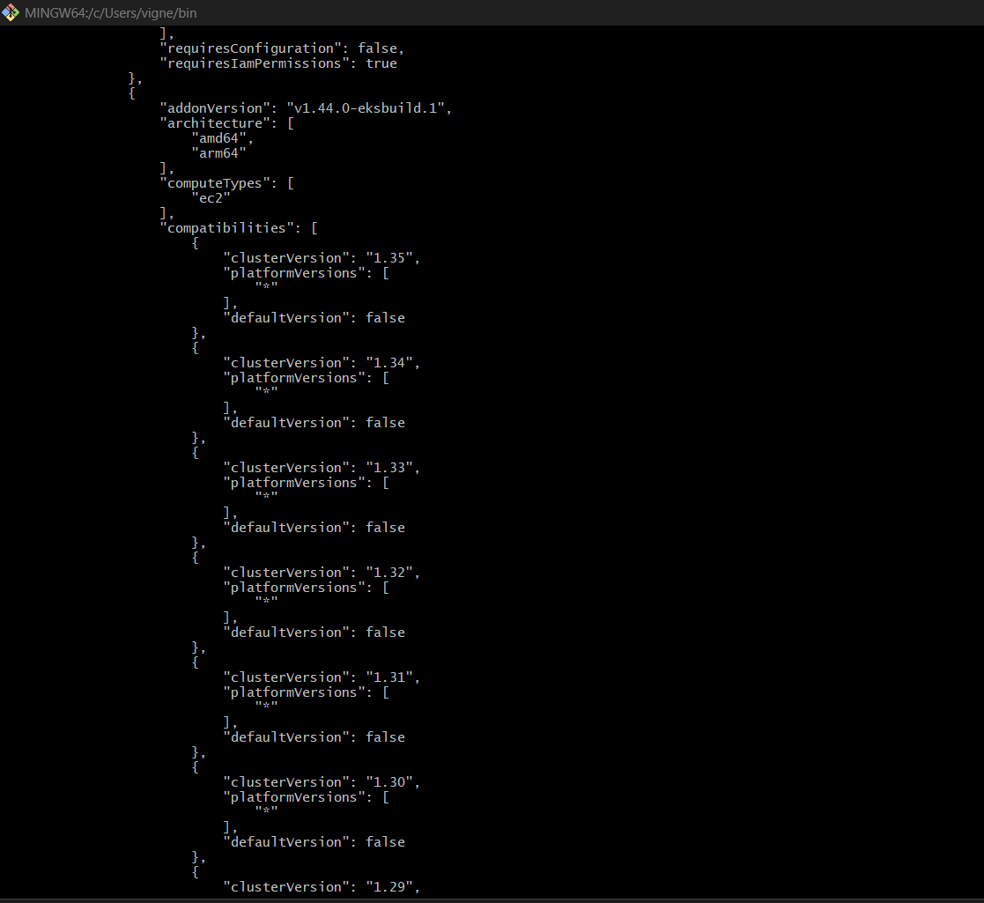
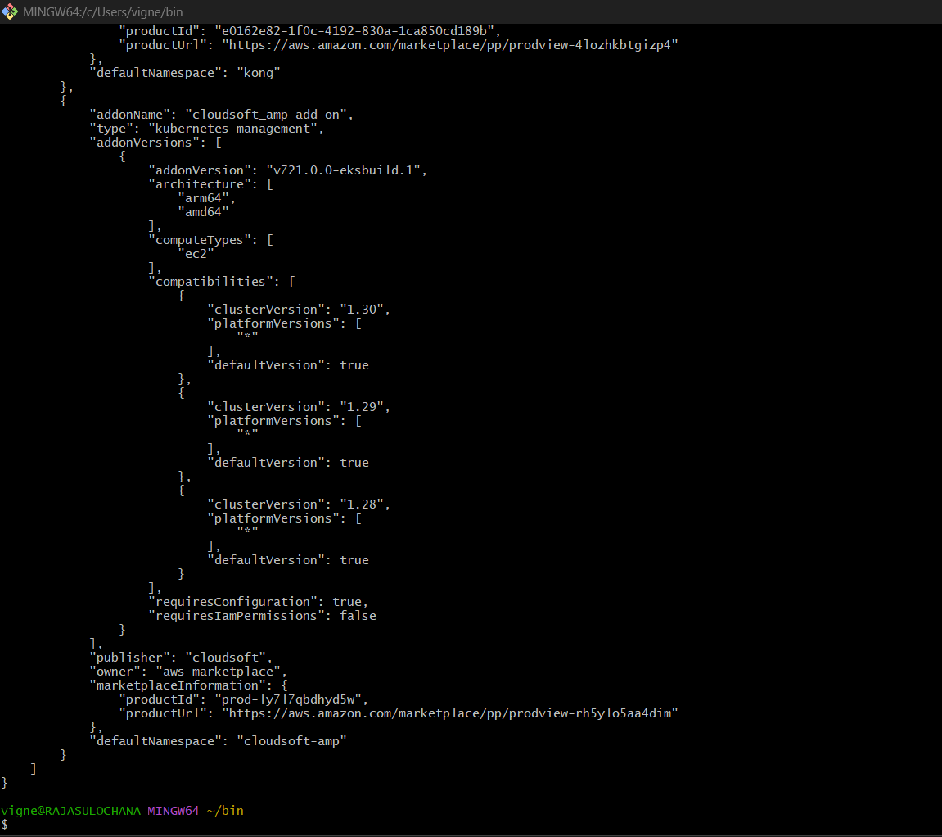

Common Add-ons you’ll see
🔹 Core ones
- vpc-cni
- coredns
- kube-proxy

🔹 Storage
- aws-ebs-csi-driver
- aws-efs-csi-driver

🔹 Observability
- aws-cloudwatch-observability
- aws-for-fluent-bit

🔹 Security / Identity
- eks-pod-identity-agent

PART 4 — Install new add-on (example)
✅ Install EBS CSI driver
aws eks create-addon \
--cluster-name my-cluster1 \
--addon-name aws-ebs-csi-driver
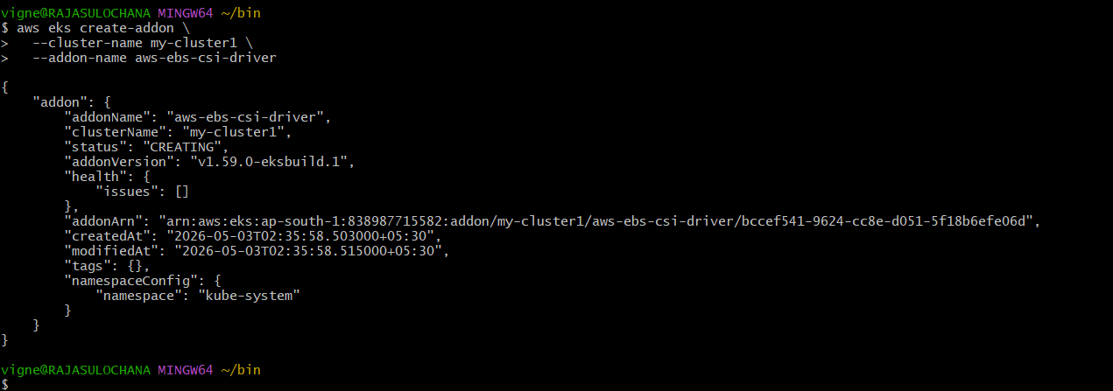

✅ Verify
aws eks list-addons --cluster-name my-cluster1
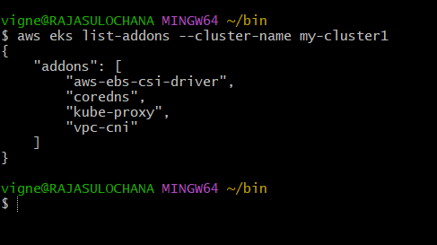

PART 5 — Check inside Kubernetes
Some add-ons run as pods:
kubectl get pods -n kube-system
👉 Example:
- aws-node (CNI)
- coredns
- kube-proxy

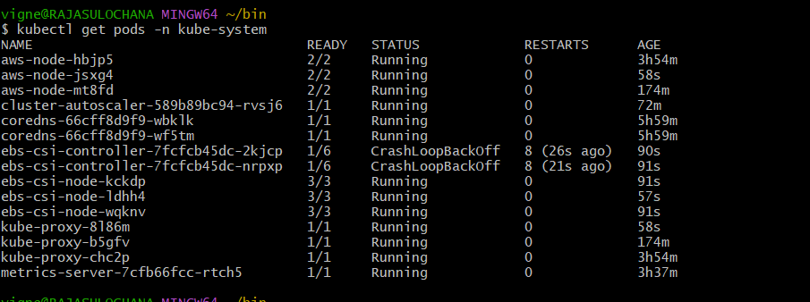

Important Points
⭐ Why add-ons?
- Simplify cluster setup
- Managed by AWS
- Easy upgrades

⭐ Difference
Manual install | EKS Add-on
You manage | AWS manages
Hard updates | Easy updates

Common Issues
❌ Add-on stuck in Creating
👉 IAM issue OR node problem

❌ Version mismatch
👉 Cluster version vs add-on version mismatch

Pro Tip
Always use:
👉 EKS Add-ons instead of manual installation

Summary
You now know:
- View add-ons (Console + CLI)
- List available add-ons
- Install new add-ons
- Verify in cluster

8) Upgrade eks cluster

What “upgrade EKS” actually means
In Amazon EKS you upgrade in two layers:
- Control plane (AWS-managed)
- Worker nodes (your node groups)
👉 Always upgrade control plane first, then nodes.

PART 0 — Pre-checks (don’t skip)
✅ Check current version
kubectl version
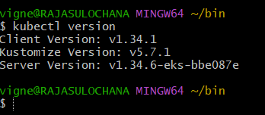
✅ Check cluster version
aws eks describe-cluster \
--name my-cluster1 \
--query "cluster.version"
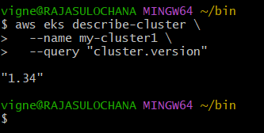
✅ Check add-ons
aws eks list-addons --cluster-name my-cluster1
👉 Note versions for:
- vpc-cni
- coredns
- kube-proxy
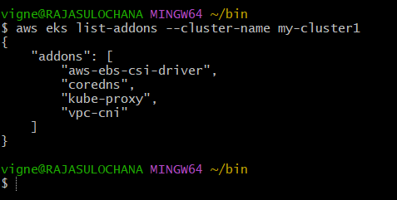

PART 1 — Upgrade using AWS Console (simplest)
✅ Step 1: Open cluster
Go to EKS → Clusters → your cluster

✅ Step 2: Upgrade control plane
- Click Update now (next to Kubernetes version)
- Select next version (e.g., 1.34 → 1.35)
- Click Update
Takes ~10–15 mins
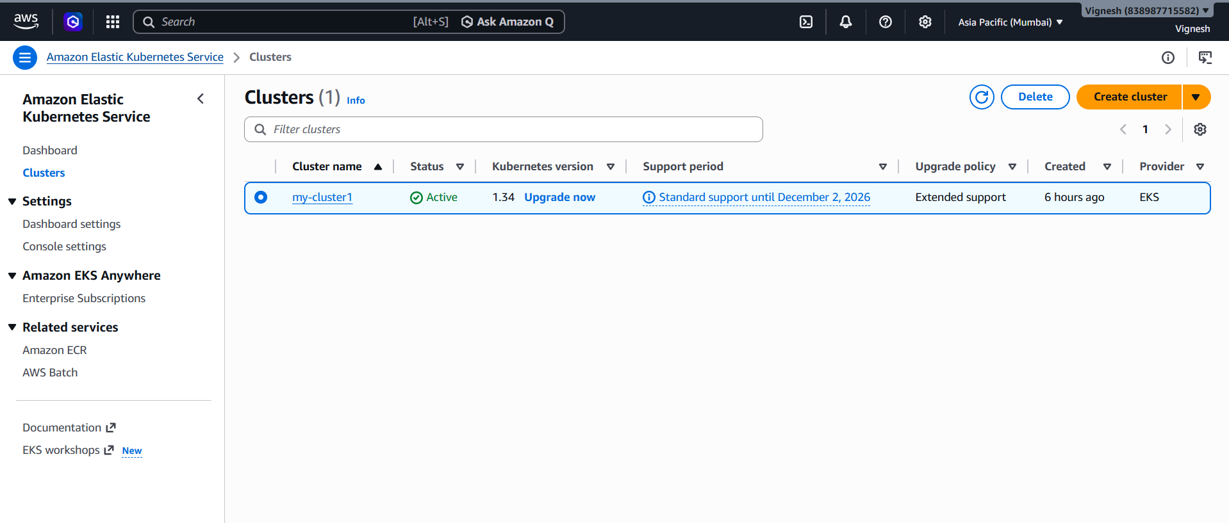

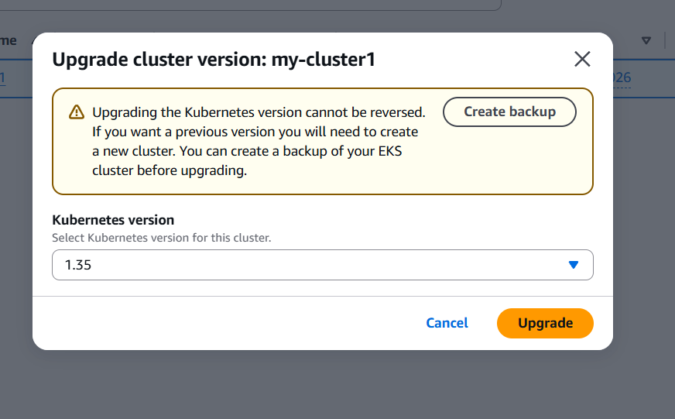
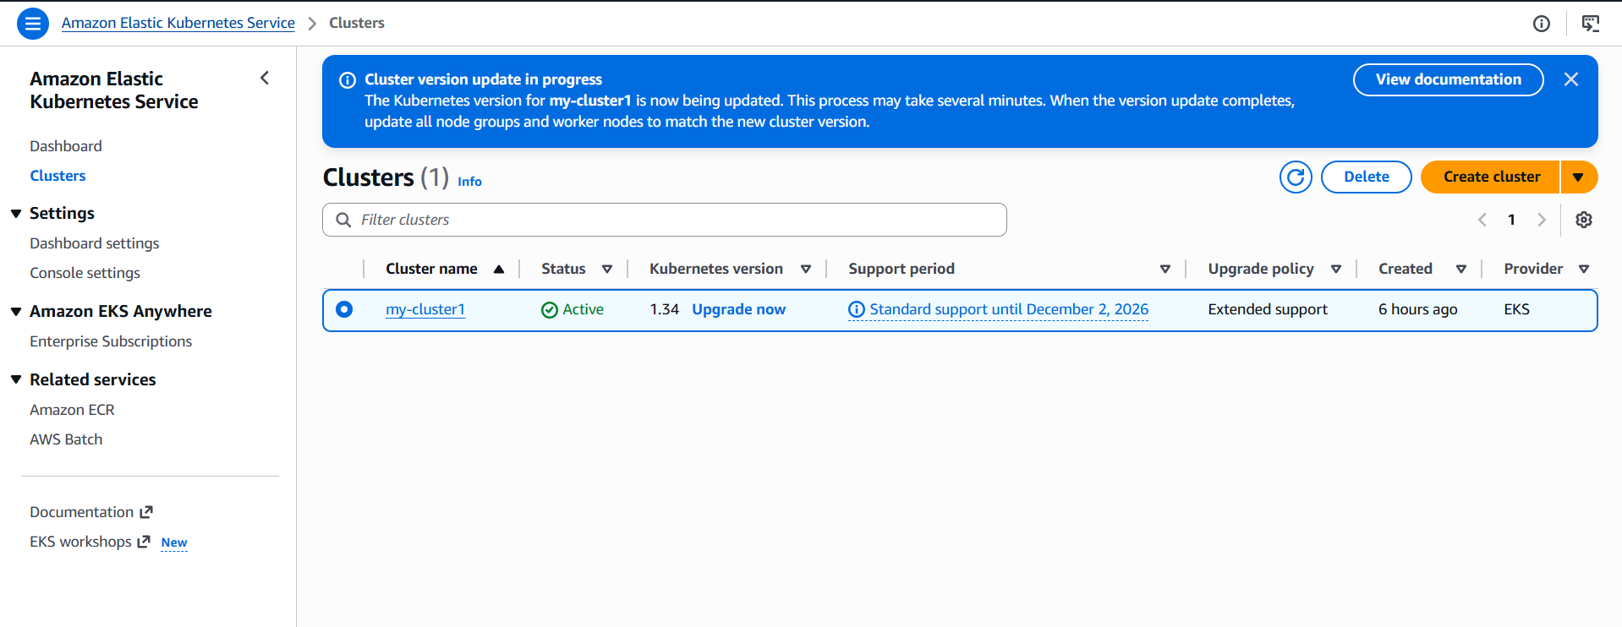
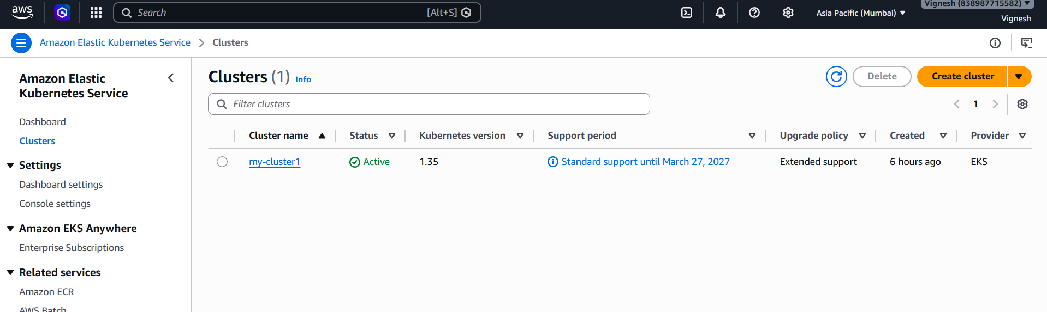

✅ Step 3: Verify
kubectl version
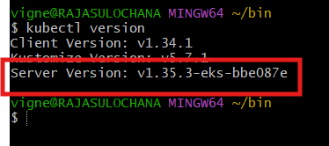

PART 2 — Upgrade Node Group (VERY IMPORTANT)
👉 Old nodes still run old version → must upgrade

Option A (Console — recommended)
Step 1: Go to Compute → Node Groups
Step 2: Select node group
Step 3: Click Update now
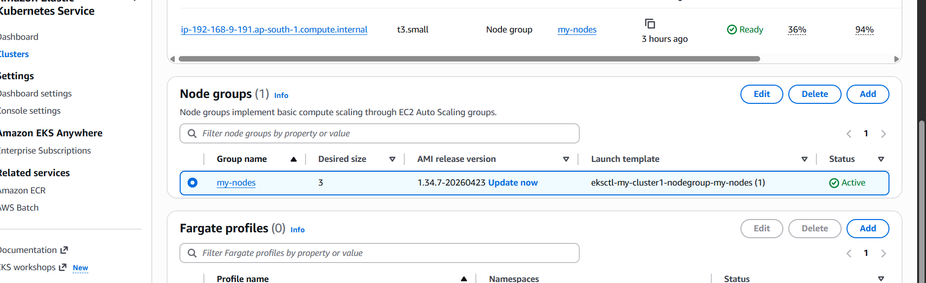
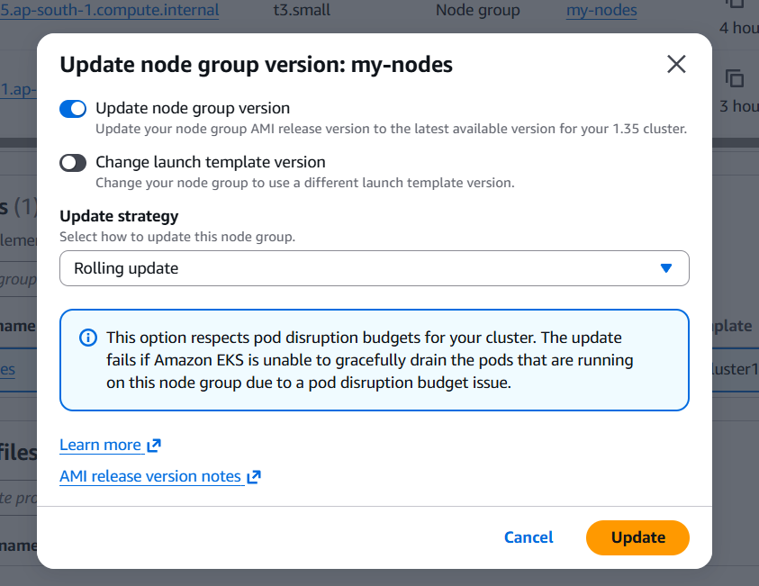
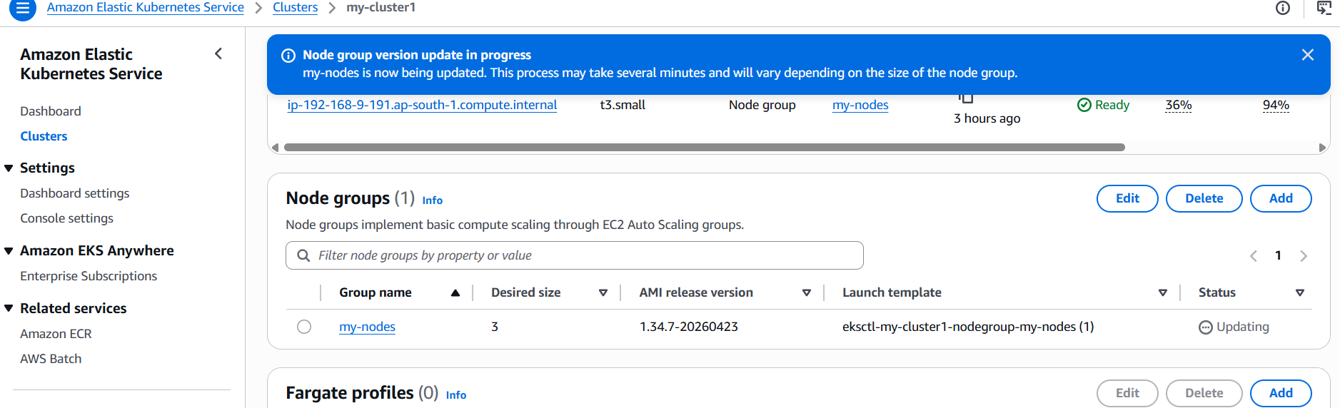
Choose:
- Latest AMI version
- Same instance type (or upgrade if needed)

Option B (Safer method — Blue/Green)
👉 Create new node group:
- Instance → t3.medium
- Latest AMI
Then:
kubectl drain <old-node>
Delete old node group after migration

PART 3 — Upgrade Add-ons
Console:
Go to Add-ons tab
👉 For each:
- Click add-on
- Click Update now

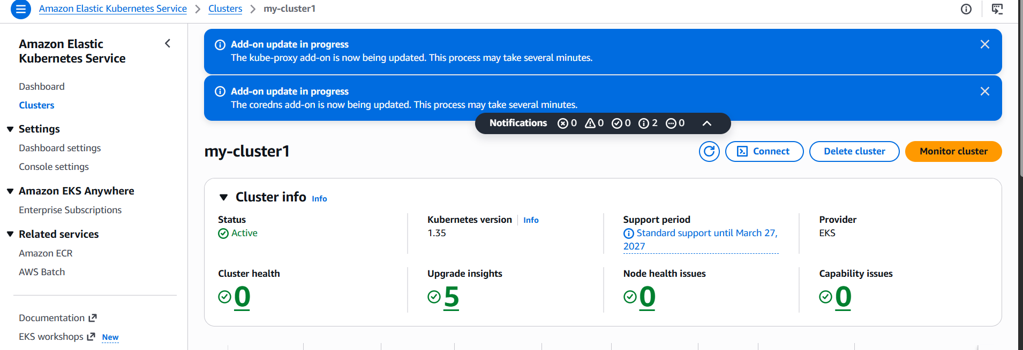
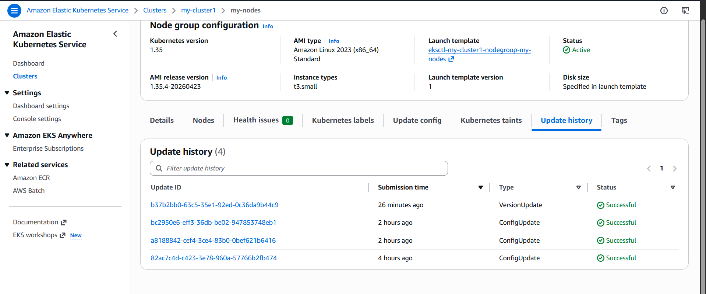

CLI:
aws eks update-addon \
--cluster-name my-cluster1 \
--addon-name vpc-cni \
--resolve-conflicts OVERWRITE
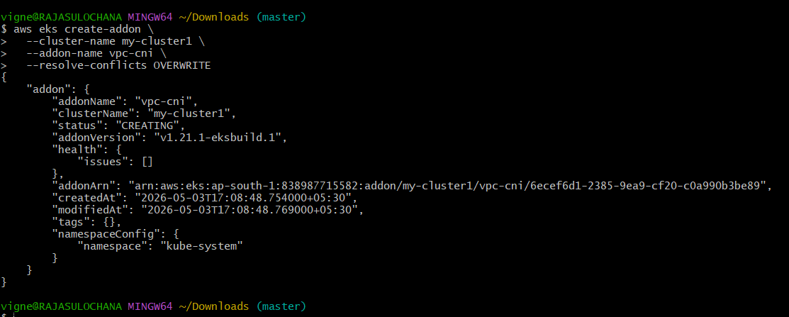

PART 4 — Verify everything
kubectl get nodes
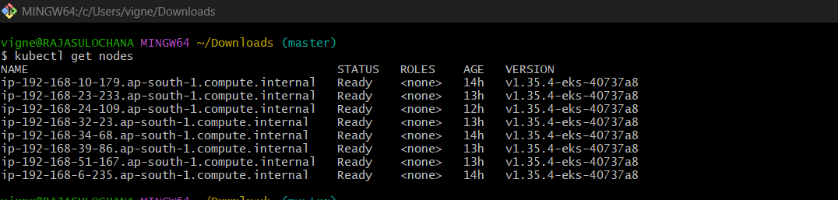
kubectl get pods -n kube-system
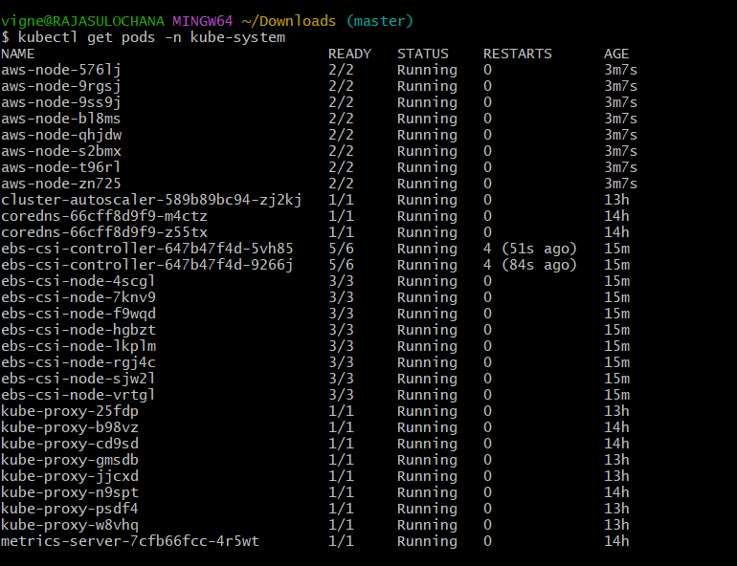
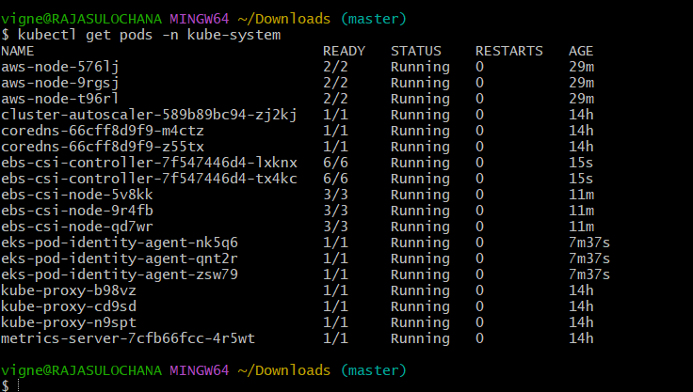

👉 Expect:
- nodes = Ready
- pods = Running

Upgrade Order (VERY IMPORTANT)
1️⃣ Control plane
2️⃣ Add-ons
3️⃣ Node groups
👉 Never upgrade nodes first ❌
Common Mistakes
❌ Skipping node upgrade
👉 Causes version mismatch
❌ Skipping add-ons
👉 CNI / DNS issues
❌ Jumping multiple versions
👉 Upgrade one version at a time
Pro DevOps Insight
- Always use blue/green node upgrade
- Avoid in-place upgrades in production
- Test workloads after upgrade

Example Flow
- 1.34 → 1.35
- Upgrade control plane
- Upgrade add-ons
- Create new node group (1.35)
- Drain old nodes
- Delete old node group

Bonus: CLI Full Upgrade Flow
# upgrade cluster
aws eks update-cluster-version \
--name my-cluster \
--kubernetes-version 1.36
# update kubeconfig
aws eks update-kubeconfig \
--name my-cluster

